Foodborne disease surveillance and outbreak investigations in Western Australia 2015 annual report



**Enhancing foodborne disease surveillance across Australia**



OzFoodNet, Communicable Disease Control Directorate

**Acknowledgments**

Acknowledgement is given to the following people for their assistance with the activities described in this report: Mr Damien Bradford, Ms Lyn O’Reilly, Dr Niki Foster, Ms Jenny Green, and the staff from the enteric, PCR and food laboratories at PathWest Laboratory Medicine WA; Mr Stan Goodchild, Mr John Coles and other staff from the Food Unit of the Department of Health, Western Australia; Public Health Nurses from the metropolitan and regional Population Health Units; and Local Government Environmental Health Officers.

**Contributors/Editors**

Barry Combs, Nevada Pingault

Communicable Disease Control Directorate

Department of Health, Western Australia

PO Box 8172

Perth Business Centre

Western Australia 6849

Email: [OzfoodnetWA@health.wa.gov.au](mailto:OzfoodnetWA@health.wa.gov.au)

Telephone: (08) 9388 4999

Facsimile: (08) 9388 4877

Web:

OzFoodNet WA Health [www.public.health.wa.gov.au/3/605/2/ozfoodnet_enteric_infections_reports.pm](http://www.public.health.wa.gov.au/3/605/2/ozfoodnet_enteric_infections_reports.pm)

OzFoodNet Department of Health and Ageing

[www.ozfoodnet.gov.au/](http://www.ozfoodnet.gov.au/)

**Disclaimer**:

Every endeavour has been made to ensure that the information provided in this document was accurate at the time of writing. However, infectious disease notification data are continuously updated and subject to change.

PUBLISHED BY

This publication has been produced by the **Department of Health, Western Australia**.

# Executive summary

This report is a summary of enteric disease surveillance activities and outbreak investigations in Western Australia (WA) in 2015.

Enteric disease causes a large burden of illness in the WA community. In WA, there are 16 enteric infections that are notifiable to the Department of Health. The Department of Health through OzFoodNet (OFN) and other agencies conducts surveillance and investigates outbreaks so that targeted interventions can be used to help prevent further transmission.

In 2015, there were 5652 notifications of enteric disease in WA, which was a rate of 218 per 100 000 population, which was 21% higher than the mean rate for the previous five years. The age group with the highest enteric disease rate was the <1 - 4 years with 652 cases per 100 000 population. The rate of enteric disease in Aboriginal people was 104% higher than non-Aboriginal people. Of the notified enteric infections with a known place of acquisition, 74% reported acquiring their infection in WA, 24% reported overseas travel and 2% reported interstate travel. Of enteric notifications reporting overseas travel, 56% had travelled to Indonesia.

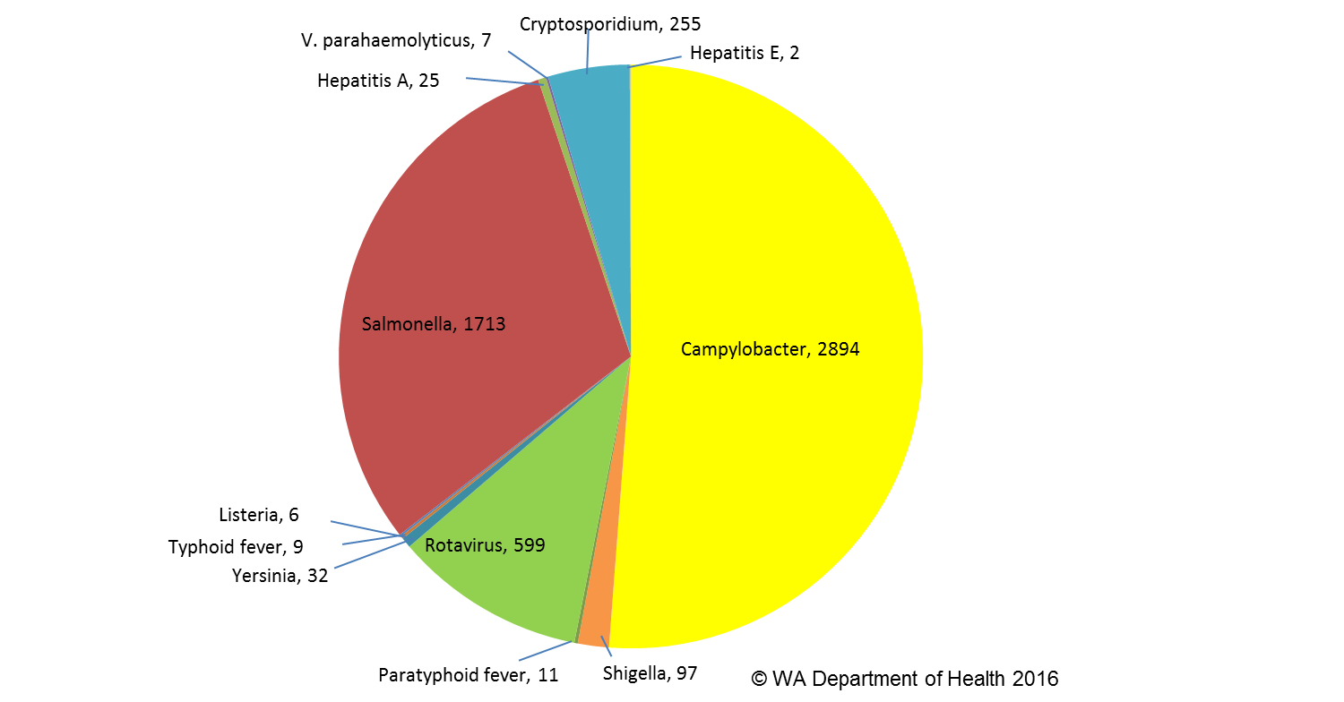

Figure A: WA enteric diseases for 2015 by disease; number of notifications

Campylobacteriosiswas the most (n=2894) commonly notified enteric disease in 2015 followed by salmonellosis (n=1713), rotavirus (n=599) and cryptosporidiosis (n=255) (Figure A). Most enteric diseases had higher rates of notifications compared to the previous five years.

**Foodborne and probable foodborne outbreaks**

In 2015, there were 10 outbreaks of foodborne or probable foodborne disease investigated in WA that caused at least 200 cases of illness (Figure B). Seven of these outbreaks were caused by *Salmonella* Typhimurium, and one outbreak each was caused by norovirus, hepatitis A and an unknown pathogen. The largest foodborne outbreak in 2015 was caused by *Salmonella* Typhimurium, and in this outbreak most people infected had consumed raw eggs prior to illness onset.

Of the 10 outbreaks, there were nine outbreaks where a food was implicated. Food vehicles identified included eggs, sandwiches, roast meats and frozen berries.

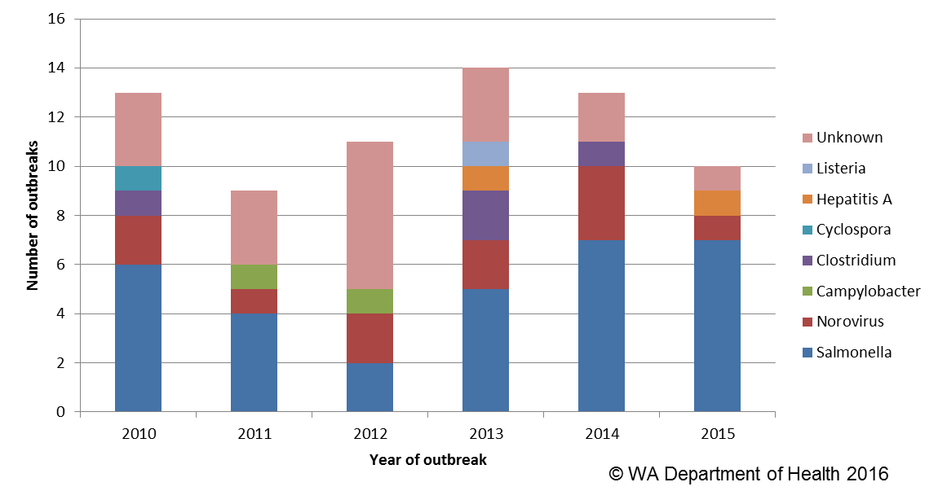

Figure B: Foodborne outbreaks investigated in WA by causative pathogen

**Non foodborne enteric disease outbreaks**

Non-foodborne enteric disease outbreaks and outbreaks with unknown mode of transmission are a major cause of illness, especially in institutions such as residential care facilities (RCF). There were 142 non-foodborne outbreaks reported in 2015 which resulted in 2872 ill people, 35 hospitalisations and 6 associated deaths. Most of these outbreaks were in RCF and due to person to person transmission.

**Table of contents**

Executive summary 3

1. Introduction 7

2. Data sources and methods 9

2.1. Data sources………………………………………………………………………… 9

2.2. Data collection by Aboriginality……………………………………………………..10

2.3. Regional boundaries………………………………………………………………... 10

2.4. Calculation of rates 10

2.5. Definitions: 10

3. Site activities including prevention measures during the year 11

3.1. Surveillance and investigation 11

3.2. Activities on enhancing laboratory and epidemiological surveillance 11

3.3. Activities to assist enteric disease policy development 12

3.4. Strengthening skills and capacity for enteric disease surveillance and investigation 12

3.5. Conference meetings and presentations 12

4. Incidence of specific enteric diseases 13

4.1. Campylobacteriosis 14

4.2. Salmonellosis 16

4.3. Rotavirus infection 19

4.4. Cryptosporidiosis 21

4.5. Shigellosis infection 23

4.6. Hepatitis A virus infection 25

4.7. Typhoid and paratyphoid fever 26

4.8. Listeriosis 26

4.9. *Vibrio parahaemolyticus* infection 27

4.10.*Yersinia* infection 27

4.11.Haemolytic Uraemic Syndrome (HUS) 27

4.12.Hepatitis E 27

4.13.Botulism 27

4.14.Cholera and STEC 27

5. Gastrointestinal disease outbreaks and investigations 28

5.1. Foodborne/probable foodborne outbreaks 28

5.2. Outbreaks due to non-foodborne transmission or with an unknown mode of transmission 32

5.3. Cluster investigations 36

6. References 38

Appendix 1: Number of notifications, notification rate and ratio of current to historical mean by pathogen/condition, 2010 to 2015, WA 38

List of tables

Table 1. Number and proportion of the top 10 *Salmonella* serotypes notified in WA, 2015, with comparison to the 5-year average 18

Table 2 Foodborne and probable foodborne outbreaks, 2015 31

Table 3. Outbreaks due to non-foodborne transmission or unknown mode of transmission in WA by setting and agent, 2015 34

Table 4. Cluster investigations in WA by month investigation started, setting and agent, 2015 38

List of figures

**Figure 1. Number of cases of campylobacteriosis by year and month of onset, WA, 2010 to 2015** 15

Figure 2: Age-specific notification rates for campylobacteriosis by sex, WA, 2015 15

Figure 3. Campylobacteriosis notification rates by Aboriginality, WA, 2010 to 2015 15

Figure 4. Campylobacteriosis notification rates by region and Aboriginality, WA, 2015 16

Figure 5. Number of cases of salmonellosis by year and month of onset, WA, 2010 to 2015 16

Figure 6. Age-specific notification rates for salmonellosis by sex, WA, 2015 17

Figure 7. Salmonellosis notification rates by region and Aboriginality, WA, 2015 17

Figure 8. Proportion of salmonellosis cases acquired overseas, by year of onset, 2010 to 2015 19

Figure 9. Number of cases of rotavirus infection by year and month of onset, WA, 2010 to 2015 19

Figure 10. Age-specific notification rates for rotavirus by sex, WA, 2015 20

Figure 11. Rotavirus notification rates by region and Aboriginality, WA, 2015 21

Figure 12. Age-specific notification rates for cryptosporidiosis by sex, WA, 2015 22

Figure 13. Cryptosporidiosis notification rates by region and Aboriginality, WA, 2015 22

Figure 14. Number of cases of shigellosis by year and month of onset, WA, 2010 to 2015 23

Figure 15. Age-specific notification rates for shigellosis by sex, WA, 2015 24

Figure 16. Shigellosis notification rates by region and Aboriginality, WA, 2015 24

Figure 17. Place of acquisition for shigellosis cases, 2010 to 2015 24

Figure 18. Place of acquisition for hepatitis A cases, 2010 to 2015 25

Figure 19. Notifications of listeriosis showing non-pregnancy related infections and deaths, and materno-foetal infections and deaths, WA, 2010 to 2015. 26

Figure 20. Number of gastroenteritis outbreaks designated as non-foodborne or with unknown mode of transmission reported in WA, in 2015 34

Figure 21. Average number of gastroenteritis outbreaks due to probable person-to-person transmission for specific months for the period 2010 to 2015 in WA. 35

Figure 22. Notifications of *Salmonella* Typhimurium PFGE 0001 in WA, May 2013 to December 2015. 36

# Introduction

It has been estimated that there are 5.4 million cases of foodborne illness in Australia each year and that the cost of this illness is estimated at $1.2 billion per year1. This is likely to be an underestimate of the cost of enteric illness in Australia as not all enteric infections are caused by foodborne transmission. Other modes of transmission are also very important causes of enteric infection including person to person, animal to person and waterborne transmission. Importantly, most of these infections are preventable through interventions at the level of primary production, institution infection control and food handling and hand hygiene at food businesses and households.

This report describes Western Australian enteric disease surveillance and investigations carried out in 2015 by OzFoodNet WA (OFN) and other Western Australian Department of Health agencies. Most of the data presented in this report is derived from enteric disease notifications from doctors and laboratories received by the Department of Health, WA (WA Health) and are likely to underestimate the true incidence of disease. This data nevertheless remain the most important information on incidence of these infections for surveillance purposes in WA. In addition, norovirus which is not notifiable, is the cause of a large burden of illness in RCF and also in the general community.

OFN is part of the Communicable Disease Control Directorate (CDCD) of WA Health. OFN in Western Australia is also part of a National OFN network funded by the Commonwealth Department of Health and Ageing 2. The mission of OFN is to enhance surveillance of foodborne illness in Australia and to conduct applied research into associated risk factors. The OFN site based in Perth is responsible for the whole of WA, which has a total population of approximately 2.6 million. Collaboration between states and territories is facilitated by circulation of fortnightly jurisdictional enteric surveillance reports, monthly teleconferences, tri-annual face-to-face meetings and through the informal network. This network also includes communication and consultation with Food Standards Australia New Zealand, the Commonwealth Department of Health and Ageing, the National Centre for Epidemiology and Population Health, the Communicable Diseases Network of Australia (CDNA) and the Public Health Laboratory Network.

The primary objectives of OFN nationally are to:

* estimate the incidence and cost of foodborne illness in Australia,
* investigate the epidemiology of foodborne diseases, by enhancing surveillance and conducting special studies on foodborne pathogens,
* collaborate nationally to coordinate investigations into foodborne disease outbreaks, particularly those that cross State, Territory and country borders,
* train people to investigate foodborne illness.

On a local level, OFN WA conducts surveillance of enteric infections to identify clusters and outbreaks of specific diseases and conducts epidemiological investigations to help determine the cause of outbreaks. OFN WA also conducts research into the risk factors for sporadic cases of enteric diseases and develops policies and guidelines related to enteric disease surveillance, investigation and control. OFN WA regularly liaises with staff from the Population Health Units (PHUs), the Food Unit (FU) in the Environmental Health Directorate of WA Health; and the Food Hygiene, Diagnostic and Molecular Epidemiology laboratories at PathWest Laboratory Medicine WA.

CDCD maintains and coordinates the WA notifiable disease surveillance system and provides specialist clinical, public health and epidemiological training and advice to PHUs. The WA notifiable diseases surveillance system relies on the mandatory reporting by doctors and laboratories for the surveillance of 16 notifiable enteric diseases and syndromes.

PHUs are responsible for public health activities, including communicable disease control, in their WA administrative health regions. There are 9 PHUs in WA: North Metropolitan, South Metropolitan, Kimberley, Pilbara, Midwest, Wheatbelt, Goldfields, South West, and Great Southern. The PHUs monitor RCF gastroenteritis outbreaks and provide infection control advice. The PHUs also conduct follow up of single cases of important enteric diseases including typhoid, paratyphoid, hepatitis A and E, cholera and *Shigella dysenteriae*. OFN will also assist with the investigation of these enteric diseases if there is a cluster and/or they are locally acquired, and will investigate RCF outbreaks if the outbreak is due probable foodborne transmission.

The FU liaises with Local Government (LG) Environmental Health Officers (EHO) during the investigation of food businesses, and coordinates food business investigations when multiple LGs are involved.

The Food Hygiene, Diagnostic and Molecular Epidemiology laboratories at PathWest Laboratory Medicine WA provide public health laboratory services for the surveillance and investigation of enteric disease.

# Data sources and methods

## **Data sources**

Data on WA cases of notifiable enteric diseases were obtained from the WA notifiable infectious disease database (WANIDD). The notifications contained in WANIDD are received from medical practitioners and pathology laboratories under the provisions of the Health Act 1911 and subsequent amendments, and are retained in WANIDD if WA (for diseases not nationally notifiable) 3 or national case definitions are met 4.

Notifiable enteric diseases included in this report are campylobacteriosis, salmonellosis, rotavirus infection, cryptosporidiosis, shigellosis, hepatitis A infection, listeriosis, typhoid fever, shiga-toxin producing *E. coli* (STEC) infection, *Vibrio parahaemolyticus* infection, yersiniosis, hepatitis E infection, paratyphoid fever, cholera, haemolytic uraemic syndrome (HUS) and botulism. In March 2016, data for these diseases were extracted from WANIDD by optimal date of onset (ODOO) for the time period 01/01/2010 to 31/12/2015, and exported to Microsoft® Excel 2007. The ODOO is a composite of the ‘true’ date of onset provided by the notifying doctor or obtained during case follow-up, the date of specimen collection for laboratory notified cases, and when neither of these dates is available, the date of notification by the doctor or laboratory, or the date of receipt of notification, whichever is earliest.

Notification data extracted for this report may have been revised since the time of extraction. Subsequent minor changes to the data would not substantially affect the overall trends and patterns.

Information on *Salmonella* serotypes and *Shigella* species was obtained from PathWest Laboratory Medicine WA, the reference laboratory for WA. Phage typing and other specialised diagnostic data were obtained from the Microbiological Diagnostic Unit, University of Melbourne; and the Australian *Salmonella* Reference Laboratory, Institute of Medical and Veterinary Science (Adelaide). Pulsed field gel electrophoresis (PFGE) typing and multi-locus variable number tandem repeat analysis (MLVA) was carried out at PathWest Laboratory Medicine WA.

Information on RCF outbreaks was collected by PHU nurses who forward collated epidemiological and laboratory data to OFN.

## **Data collection by Aboriginality**

For the purposes of this report, the term ‘Aboriginal’ is used in preference to ‘Aboriginal and Torres Strait Islander’ to recognise that Aboriginal people are the original inhabitants of WA.

In WA, there is considerable mobility of Aboriginal people, both within WA and across the Northern Territory and South Australia borders, which means that some Aboriginal people will be patients of more than one health service. Due to the small size of the Aboriginal population in WA (3.1% of the total population in 2015) and the large number of cases reported in Aboriginal people, inaccuracies in the population estimates of Aboriginal people can have a disproportionate impact on calculated rates. In the preparation of this report, these factors are acknowledged as limitations. Information on Aboriginality is also missing in many instances.

## **Regional boundaries**

Notification data are broken down by regions that are based on PHU boundaries, reflecting WA Health administrative regions Metropolitan Perth (METRO), SouthWest (STHWA), Great Southern (GTSH), Goldfields (GOLD), Central (CENT), Midwest (MIDW), Pilbara (PILB) and Kimberley (KIMB). PHU contact numbers and details are outlined at the website location in reference 5.

## **Calculation of rates**

WA’s estimated resident population figures used for calculation of rates were obtained from Rates Calculator version 9.5.5 (WA Health, Government of Western Australia). The Rates Calculator provides population estimates by age, sex, Aboriginality, year and area of residence, and is based on population figures derived from the 2011 census. The estimated population for WA in 2015 was 2 595 393 persons. Rates calculated for this report have not been adjusted for age.

## **Definitions:**

**Foodborne outbreak** is an incident where two or more persons experience a similar illness after consuming a common food or meal and epidemiological analyses implicate the meal or food as the source of illness.

**Probable foodborne outbreak** is an incident where two or more persons experience a similar illness after consuming a common food or meal and a specific meal or food is suspected, but another mode of transmission cannot be ruled out.

**Person-to-person outbreak** is an incident where two or more persons experience a similar illness after exposure to an infected person.

**Unknown outbreak transmission** is an incident where two or more persons experience a similar illness but the mode of transmission is unable to be determined.

# Site activities including prevention measures during the year

During 2015 the following activities and prevention measures were conducted at the WA OFN site.

## **Surveillance and investigation**

* Ongoing surveillance of infectious enteric disease in WA.
* Investigation of 10 local foodborne or probable foodborne outbreaks, five *Salmonella* clusters and one *Yersinia* cluster.
* Investigation of six *Listeria* *monocytogenes* cases.
* Surveillance of 11 paratyphoid and 9 typhoid cases.
* Investigation of *S.* Enteritidis cases with unknown travel history and interviews of 12 locally acquired cases with a hypothesis generating questionnaire to identify risk factors for the cause of illness.
* Investigation of 123 probable person-to-person gastroenteritis outbreaks, including 71 which occurred in RCFs, 33 in child care centres and 10 in hospitals. Investigation of 17 gastroenteritis outbreaks with unknown mode of transmission were conducted with 13 occurring at RCFs, and one each at a hospital, childcare centre, private residence and accommodation vessel. Two gastroenteritis outbreaks were investigated that were from probable water-borne transmission due to *Salmonella* and *Cryptosporidium*.
* Participation in monthly national OFN teleconferences.

## **Activities on enhancing laboratory and epidemiological surveillance**

* Ongoing bi-monthly meetings with PathWest and Food Unit staff.
* Provided enteric disease data, interpretation and advice upon request to local government environmental health officers, laboratory and public health unit staff.
* Monitoring enteric disease notifications in WA since the introduction of culture independent testing (e.g. PCR) of enteric pathogens.
* Participation in monthly national OzFoodNet teleconferences.

## **Activities to assist enteric disease policy development**

* Finalised update of WA Health operational directive ‘Guidelines for exclusion of people with enteric infections and their contacts from work, school and child care settings’.
* Chairing the Series of National Guidelines (SoNG) working group for *Listeria* infection.
* Membership of OzFoodNet working groups on:
  + National STEC surveillance
  + Outbreak register
  + Foodborne disease tool kit
  + Egg-related outbreaks
  + Culture-independent testing
* Membership of national working groups on the:
  + Review of the SoNG for Hepatitis A
  + Rotavirus Surveillance
* Six monthly meeting with Environmental Health, Communicable Disease Control Directorate (including OzFoodNet) from the Department of Health and the Department of Agriculture and Food to discuss zoonotic diseases in WA.

## **Strengthening skills and capacity for enteric disease surveillance and investigation**

* Continued development and implementation of the national OzFoodNet strategic plan in Newcastle, November 2015.
* Together with the Food Unit, City of Mandurah and PathWest, conducted training in Mandurah in November for environmental health officers at a one day workshop titled “Foodborne outbreak investigation training”.
* Participation in the OzFoodNet Advanced Outbreak Investigation Workshop in Newcastle in November 2015.

## **Conference meetings and presentations**

* Attendance at the OzFoodNet face-to-face meeting in Darwin in March and presented a talk on a *Salmonella* outbreak in a WA prison.
* Attendance at the OzFoodNet face-to-face meeting in Adelaide in June and presented a talk on national *Salmonella* Enteritidis notifications.
* Presentations on “Gastroenteritis outbreaks in WA aged care facilities” and “Gastroenteritis outbreak management for aged care facilities” at the Contemporary Issues in Infection Control for South West Residential Aged Care Facility Staff forum in Busselton in April
* **“Enteric disease in Kimberley/Pilbara regions” presentation at the Kimberley Aboriginal Environmental Health Working Group Forum in June at Broome.**
* **“Gastroenteritis outbreaks in WA, 2014” presentation at the Healthcare Associated Infection Surveillance Western Australia quarterly update in June.**
* Attendance at the ‘Embracing the Genomic Revolution – Applied Microbial Genomics in Public Health and Clinical Microbiology’ symposium in Melbourne in July.
* Attended the national OzFoodNet face to face meeting in Newcastle in November.
* Presented lectures and a practical on foodborne disease to Masters-level students from University of Western Australia.
* Enteric disease update for Public Health Unit nurses in November.

# Incidence of specific enteric diseases

In 2015, there were 5652 notifications of enteric disease in WA, which was a rate of 218 per 100 000 population. This rate was 21% higher than the mean rate for the previous five years of 180 per 100 000 population. The overall rate is heavily influenced by *Campylobacter* and *Salmonella* infections which comprise 51% and 30% of notifications, respectively. The age group with the highest enteric disease rate was the <1 - 4 years with 652 cases per 100 000 population, which is nearly three times the overall rate for WA. In 2015, Aboriginal people had a rate of 400 cases per 100 000 population which was 104% higher than non-Aboriginal people (196 cases per 100 000 population). The age group with the highest rate among Aboriginal people was the <1-4 years with a rate of 2357 cases per 100 000 population, compared to <1-4 year rate for non-Aboriginal people with 523 cases per 100 000 population. The region with the highest rate was the KIMB region with 606 cases per 100 000 population which was nearly three times higher than the GOLD and PILB regions which had the next highest rates (215 cases per 100 000 population and 206 cases per 100 000 population, respectively). The KIMB region has the highest rates for both Aboriginal and non-Aboriginal people with rates of 837 and 402 per 100 000 population respectively. Of the notified enteric infections with a known place of acquisition, 74% reported acquiring their infection in WA, 24% reported overseas travel and 2% reported interstate travel. Of enteric notifications reporting overseas travel, most (56%) had travelled to Indonesia.

# Campylobacteriosis

Campylobacteriosis was the most commonly notified enteric infection in 2015 with 2894 notifications and a rate of 112 per 100 000 population. This notification rate was 5% lower than the 2014 rate, but 19% higher than the previous five years average (Appendix 1 and Figure 1). In 2015, notifications decreased in February and increased in September, peaking in October. In 2015, the campylobacteriosis notification rate for males was higher than for females (123 and 100 per 100 000 population, respectively). The highest rates in younger age groups was in the <1-4 age group (137 per 100 000 population) and then decreased in older children before increasing again in the 20-29 year age group before decreasing again in older adults to middle age groups (Figure 2). The age groups with the highest notification rates were over 65 years with the highest rate in the 75-79 age group (178 per 100 000 population).

For the last five years the notification rate for non-Aboriginal people has been consistently higher than Aboriginal people and for 2015, the rate for non-Aboriginal people was 73% higher (103 and 60 per 100 000 population, respectively) (Figure 3). The 2015 notification rate for campylobacteriosis was highest in the STHW region and GTSH regions (139 cases per 100 000 population). The region with the lowest rate was the KIMB (79 per 100 000 population) (Figure 4). Of those campylobacteriosis cases with known place of acquisition, most (75%) people acquire their illness in WA with 23% of people acquiring their illness overseas. Indonesia was the most common (59%) country of acquisition.

At least some of the increase in campylobacteriosis notifications is likely to be due to the introduction by one large private pathology laboratory of polymerase chain reaction (PCR) testing of faecal specimens, which has greater sensitivity than culture techniques.

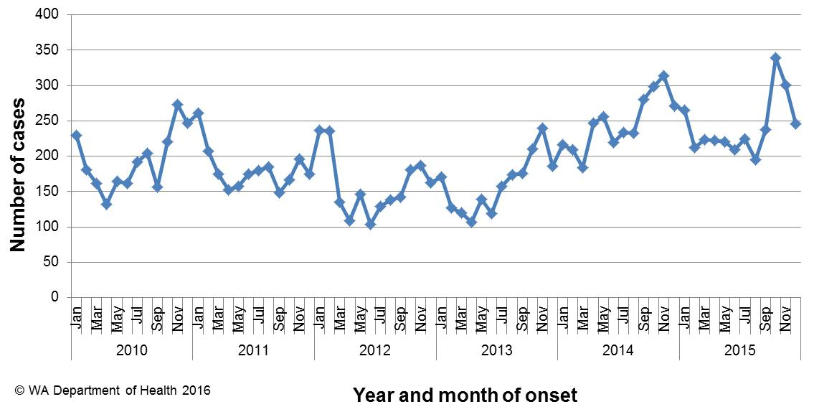

**Figure 1. Number of cases of campylobacteriosis by year and month of onset, WA, 2010 to 2015**

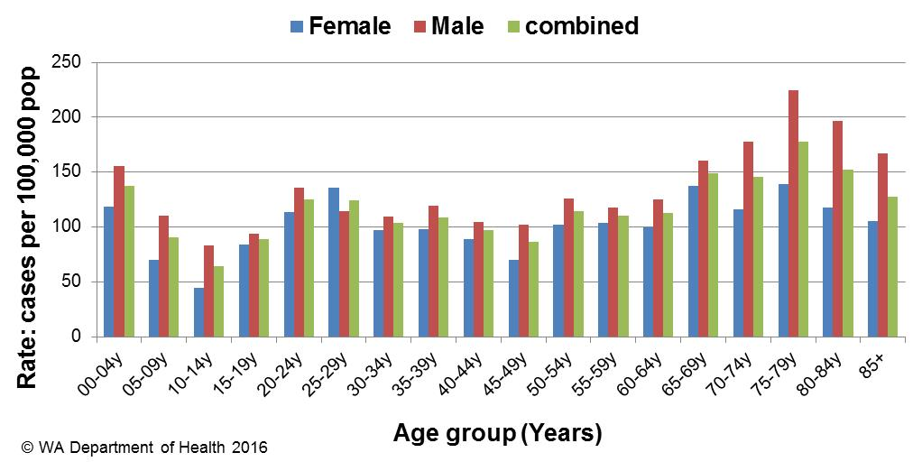

Figure 2: Age-specific notification rates for campylobacteriosis by sex, WA, 2015

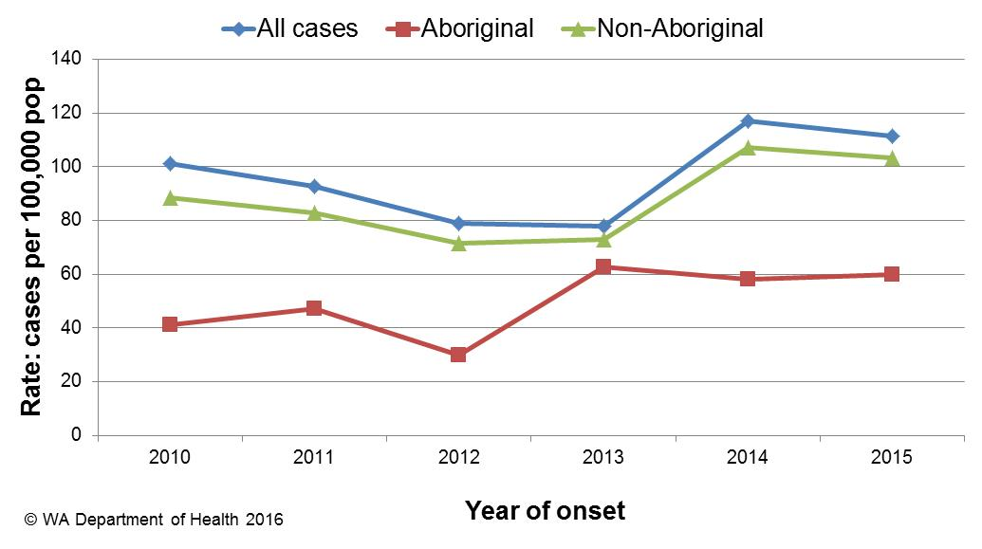

Figure 3. Campylobacteriosis notification rates by Aboriginality, WA, 2010 to 2015

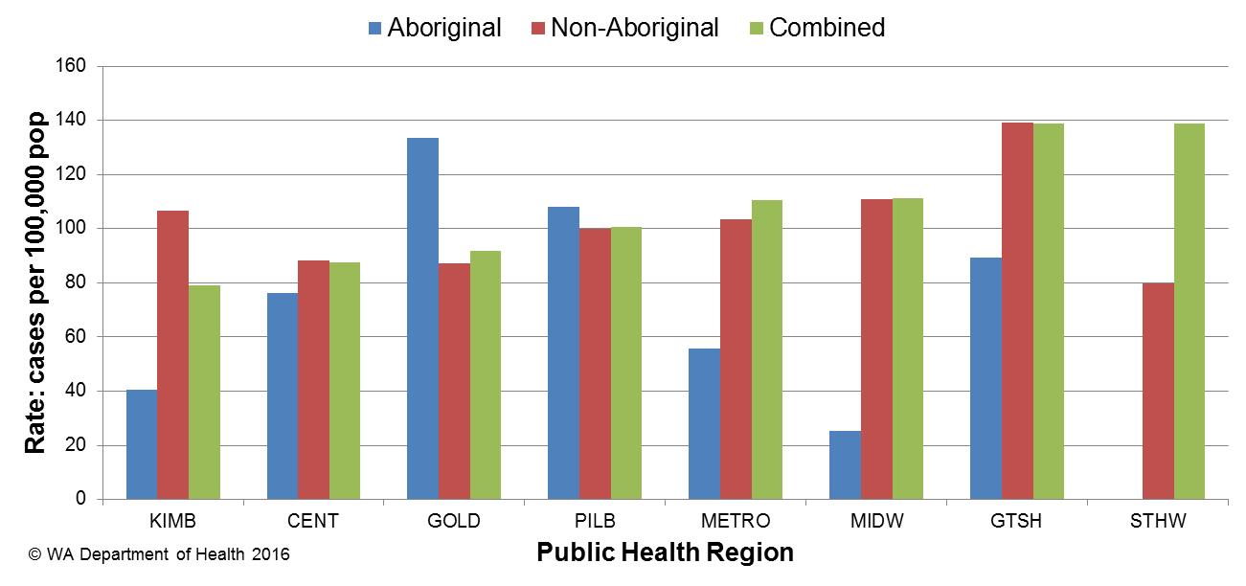

Figure 4. Campylobacteriosis notification rates by region and Aboriginality, WA, 2015

# Salmonellosis

Salmonellosis, which is an infection due to *Salmonella,* was the second most commonly notified enteric infection in WA in 2015, with 1713 cases (Appendix 1). The salmonellosis notification rate for 2015 was 66 cases per 100 000 population which is 27% higher than the previous five year average (52 cases per 100 000 population). The number of salmonellosis notifications was generally highest in the summer months but peaked in March 2015 (Figure 5).

The notification rate for females and males was similar (68 and 64 per 100 000 population, respectively). As in previous years, the <1- 4 year age group had the highest notification rate (236 per 100 000 population) (Figure 6). The age group 85 plus years, had the next highest notification rates (82 per 100 000 population)

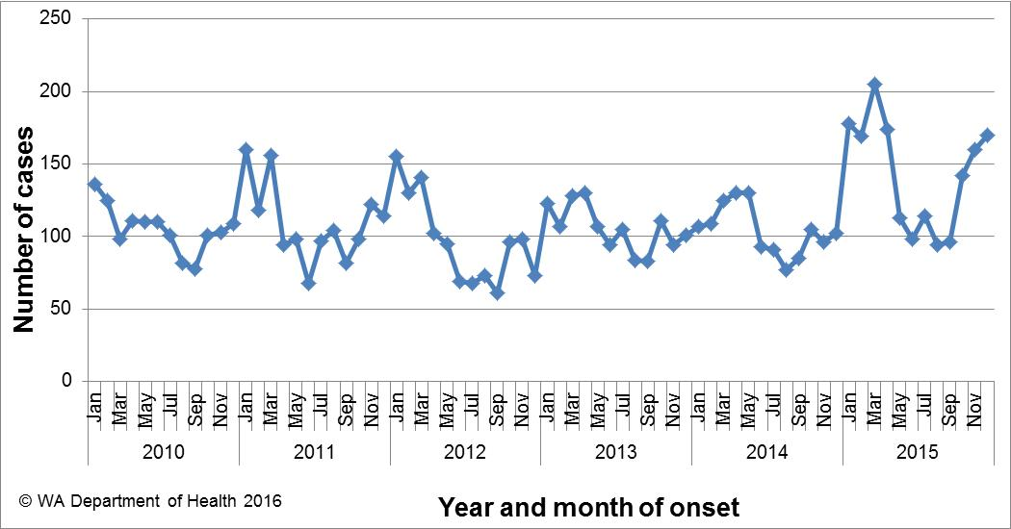

Figure 5. Number of cases of salmonellosis by year and month of onset, WA, 2010 to 2015

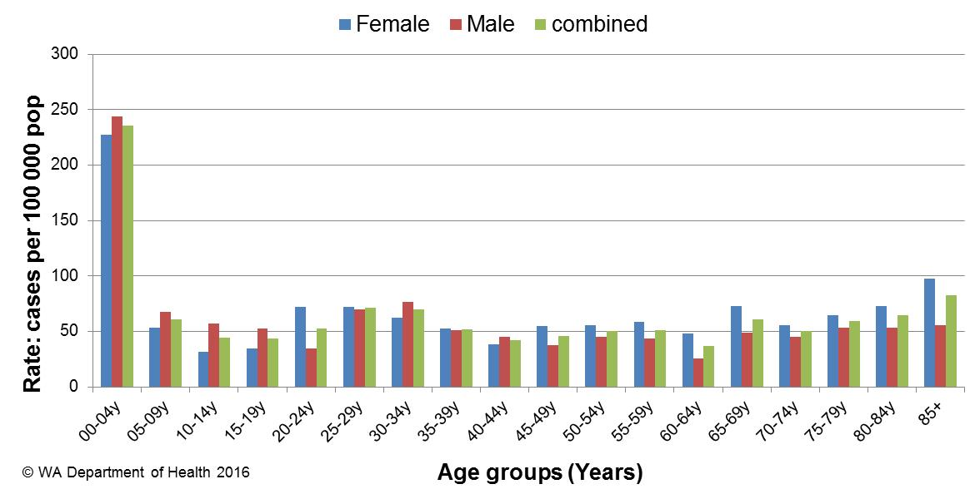

Figure 6. Age-specific notification rates for salmonellosis by sex, WA, 2015

The overall salmonellosis notification rate for Aboriginal people was 161 cases per 100 000 population, which was nearly 2.7 times the notification rate for non-Aboriginal people at 59 cases per 100 000 population.

The Kimberley region had the highest notification rate in 2015 (239 per 100 000 population) which was 5.1 times the rate for the GTSH region, which had the lowest notification rate at 47 cases per 100 000 population. In the KIMB region, rates were higher for both Aboriginal and non-Aboriginal people when compared with other regions (Figure 7).

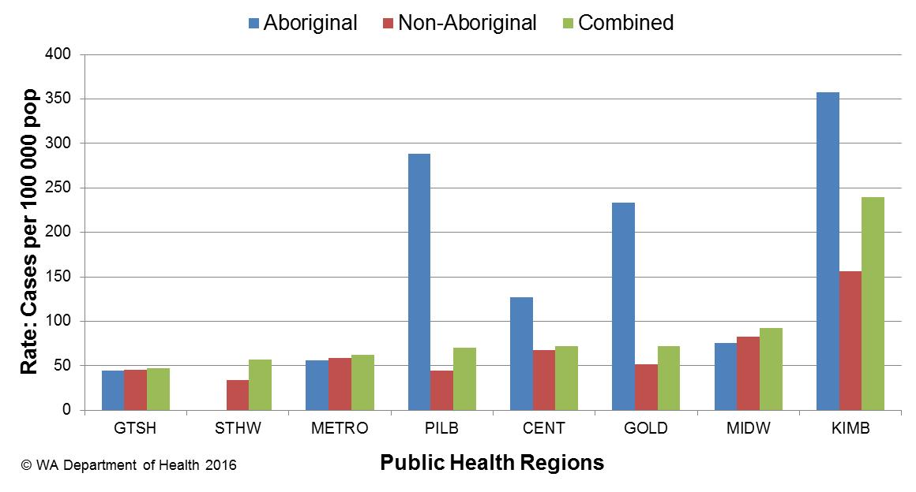

Figure 7. Salmonellosis notification rates by region and Aboriginality, WA, 2015

The most commonly notified *Salmonella* serotype in WA in 2015 was *S.* Typhimurium (STM), with 631 notifications (Table 1), which was 71% higher than 2014 and 77% higher than the mean of the previous five years. There were seven foodborne outbreaks caused by STM (Section 5.1) with five due to STM with pulsed-field gel electrophoresis (PFGE) type 0001. There were 30 confirmed cases of STMPFGE1 associated with these five outbreaks. In 2015, there were an additional 315 community (sporadic) cases of STMPFGE1 that could not be linked to a point-sourced outbreaks. Raw/runny egg consumption was the main hypothesis for the cause of illness in these community cases (see section 5.3). The next most common STMPFGE type was 0003 (n=39), which was the cause of an outbreak in a prison (See Table 2).

The second most commonly notified serotype was *S*. Enteritidis with 232 notifications which is a 13% increase on the mean of the previous five years with 205 notifications. In 2015, 93% (215/232) of cases with *S*. Enteritidis infection travelled overseas during their incubation period and of these cases, 66% (n=141) had travelled to Indonesia. There were 12 (5%) cases of *S*. Enteritidis that appeared to be locally acquired and these were interviewed to determine possible risk factors for the cause of illness, but no common source was identified.

Notifications for *S*. Kiambu*, S*. Virchow and *S*. Stanley were substantially higher in 2015 compared to the five year mean. Most cases of *S*. Kiambu and *S*. Virchow acquired their illness in Western Australia and most cases of *S*. Stanley acquired their illness overseas.

Table 1. Number and proportion of the top 10 *Salmonella* serotypes notified in WA, 2015, with comparison to the 5-year average



*Percentage of total *Salmonella* cases notified in 2015

‡Ratio of the number of reported cases in 2015 compared to the five year mean of 2010-2014.

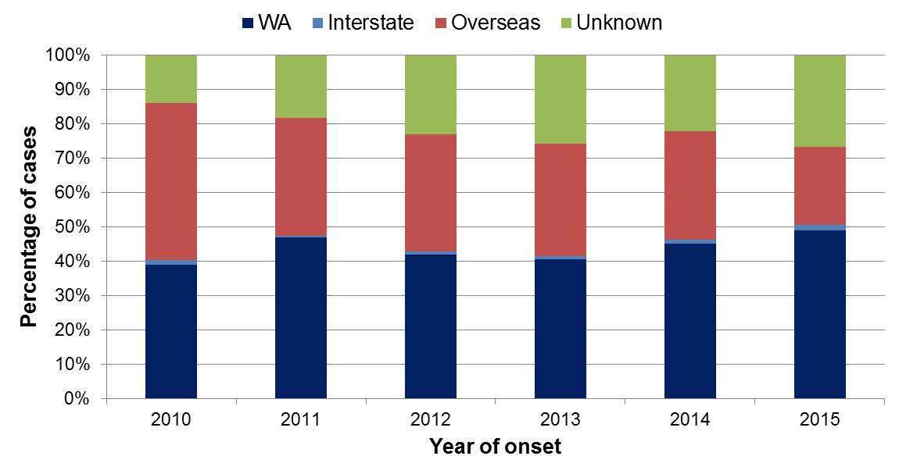

Figure 8. Proportion of salmonellosis cases acquired overseas, by year of onset, 2010 to 2015

# Rotavirus infection

There were 599 cases of rotavirus infection in WA in 2015 (23.1 per 100 000 population), making rotavirus the third most commonly notified enteric infection. The notification rate in 2015 was 55% higher than the previous three year average of 14.9 cases per 100 000 population (Appendix 1). Historically, rotavirus notifications typically peak in the winter months (Figure 9) and in 2015 rotavirus notifications also followed this seasonal pattern.

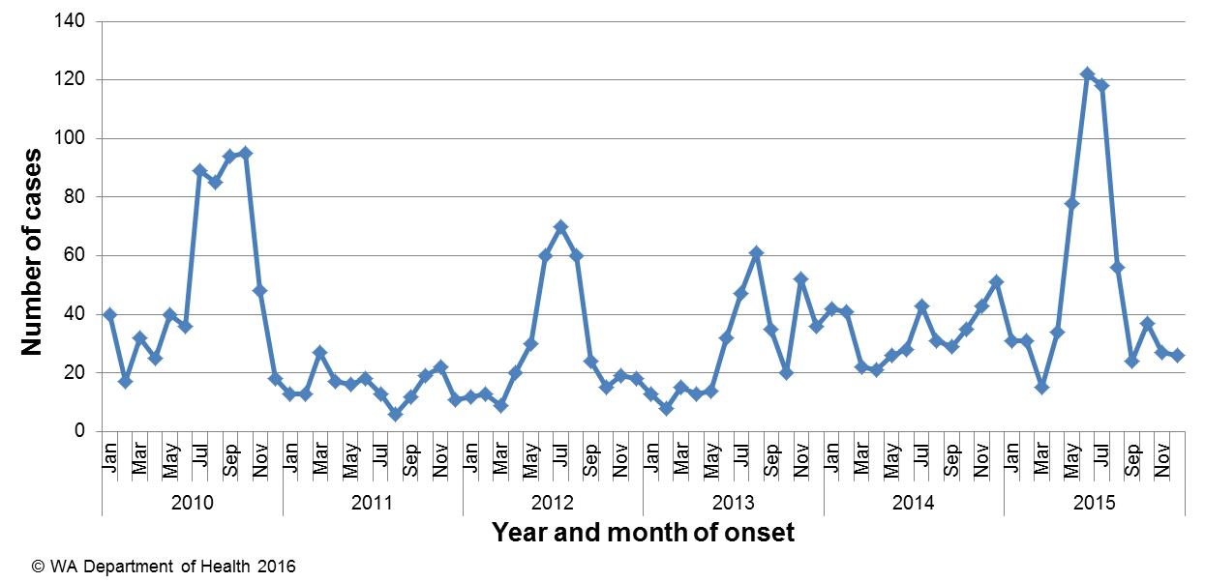

Figure 9. Number of cases of rotavirus infection by year and month of onset, WA, 2010 to 2015

As in previous years, the age group with the highest rotavirus notification rate in 2015 was the <1- 4 years group (205 cases per 100 000 population), the age cohort for which vaccination was available, followed by the oldest age group, the 80+ years group (55 cases per 100 000 population) (Figure 10). The overall notification rate was similar for females and males (23.6 and 22.6 per 100 000 population, respectively).

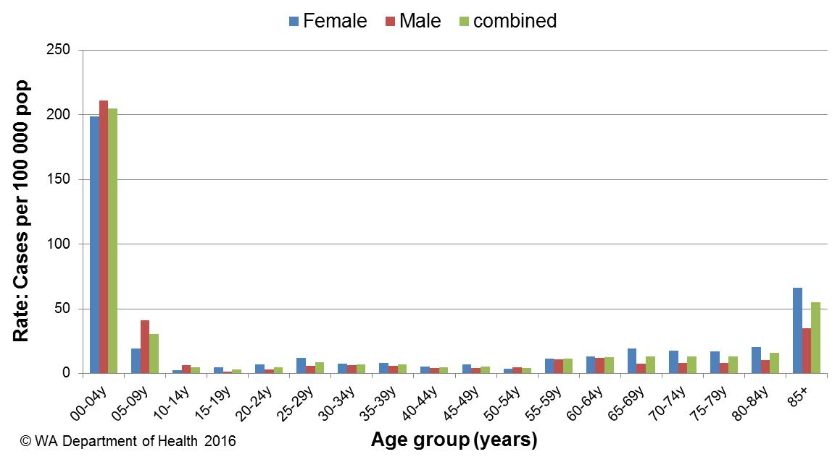

Figure 10. Age-specific notification rates for rotavirus by sex, WA, 2015

The regions with the highest rotavirus notification rates in 2015 were the KIMB and PILB regions (55 and 46 cases per 100 000 population, respectively) (Figure 11). Overall notification rates were 3.1 times higher for Aboriginal than for non-Aboriginal people (64 and 20 per 100 000 population, respectively). Of those rotavirus cases with known place of acquisition, most (95%) people acquired their illness in WA with 4% of people acquiring their illness overseas. There were eight person-to-person outbreaks due to rotavirus with four in metropolitan residential care facilities, three in childcare facilities and one in a rural institution (see Table 3).

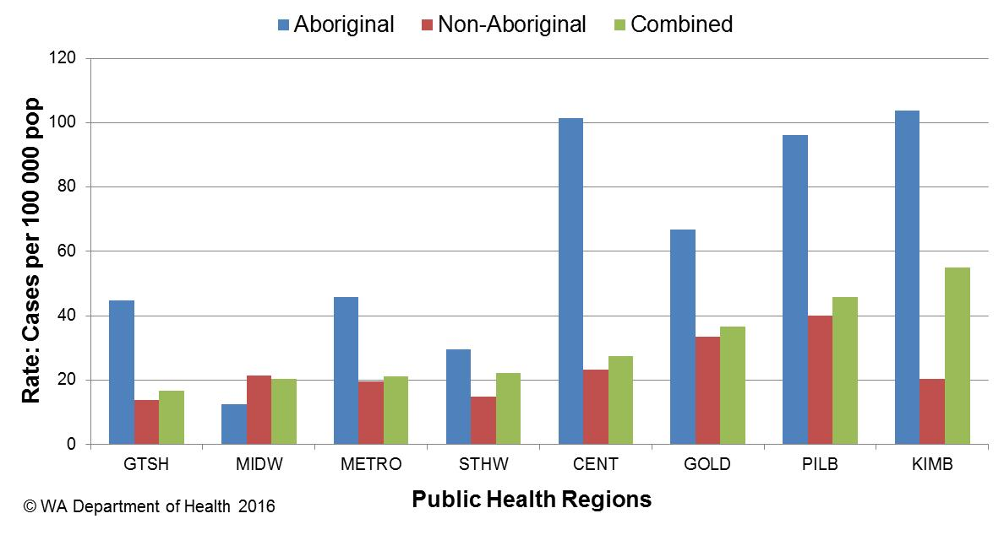

Figure 11. Rotavirus notification rates by region and Aboriginality, WA, 2015

# Cryptosporidiosis

There were 255 cryptosporidiosis cases notified in 2015, which was the fourth most common notifiable enteric disease. The notification rate (9.8 cases per 100 000 population) was 18% less than the mean of the previous five years (11.9 cases per 100 000 population) (Appendix 1). In each of the years from 2010 to 2015 cryptosporidiosis case numbers were higher in the late summer through to autumn (Figure 12).

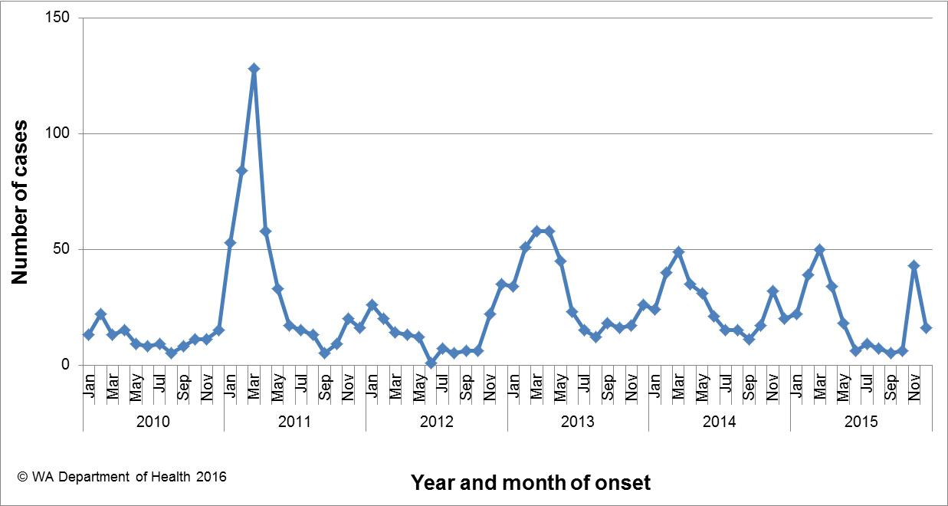

Figure 12. Number of cases of cryptosporidiosis by year and month of onset, WA, 2010 to 2015

The cryptosporidiosis notification rate was 23% higher in females than males in 2015 (10.8 and 8.8 per 100 000 population, respectively). The <1- 4 years age group had the highest notification rate (54 per 100 000 population), and accounted for 38% of all cryptosporidiosis notifications (Figure 12). The overall notification rate for the Aboriginal population was 7.4 times the rate for the non-Aboriginal population (56 and 7.6 cases per 100 000 population, respectively). The KIMB region had the highest notification rate (136 cases per 100 000 population), and the GOLD region the lowest notification rate (2 cases per 100 000 population) (Figure 13). Of those cryptosporidiosis cases with known place of acquisition, most (88%) people acquired their illness in WA, with 11% of people acquiring their illness overseas.

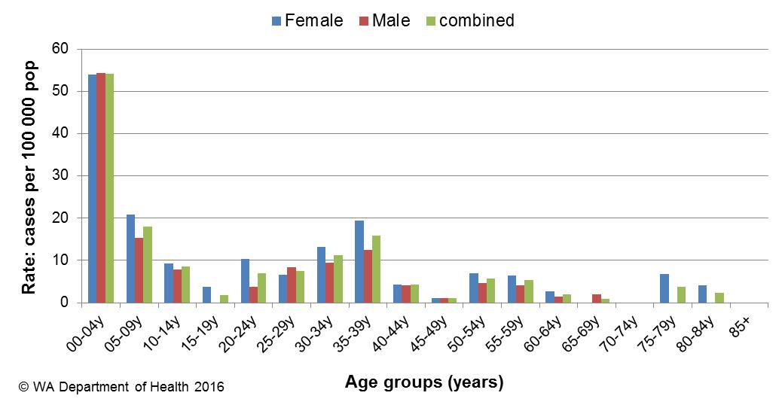

Figure 12. Age-specific notification rates for cryptosporidiosis by sex, WA, 2015

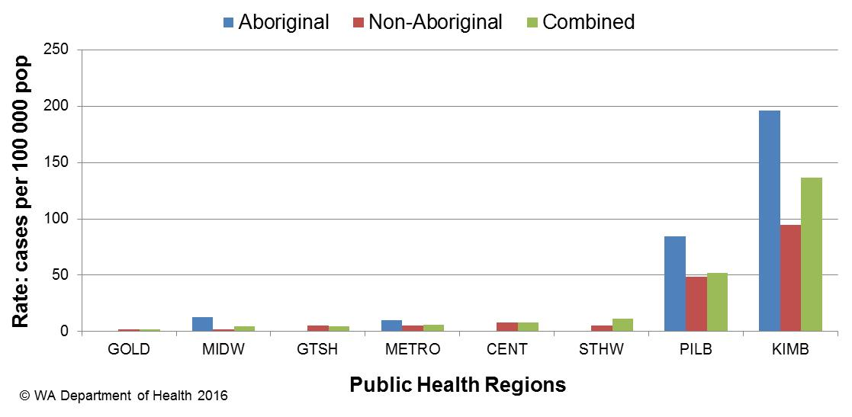

Figure 13. Cryptosporidiosis notification rates by region and Aboriginality, WA, 2015

# Shigellosis infection

There were 97 shigellosis notifications in 2015, with a notification rate of 3.7 per 100 000 population, 14% higher than the previous five year average (Appendix 1). The number of notifications was highest in January and February of 2015 (Figure 14).

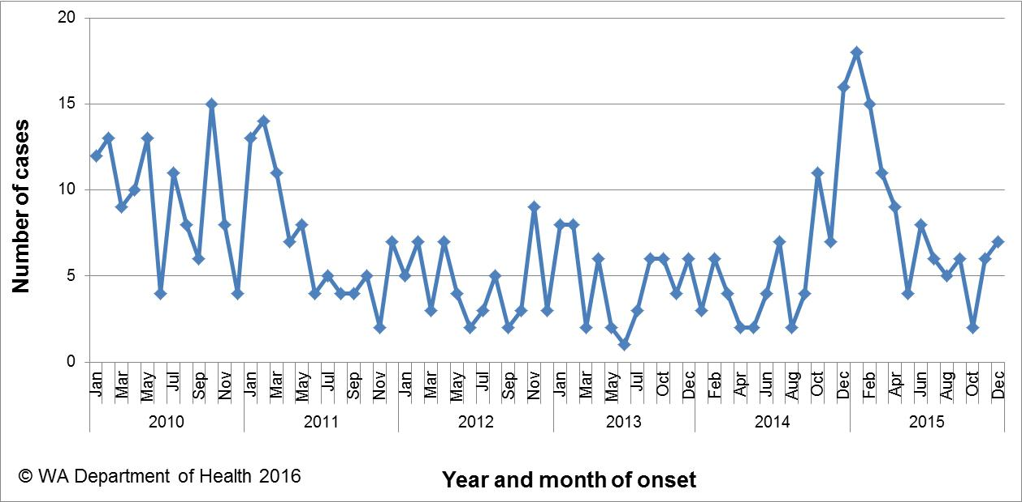

Figure 14. Number of cases of shigellosis by year and month of onset, WA, 2010 to 2015

The shigellosis notification rate was higher for females than for males in 2015 (4.5 and 3.0 per 100 000 population, respectively). The <1 to 4 years was the age group with the highest rate of infection with 13 cases per 100 000 population (Figure 15). The population health region with the highest notification rates was the KIMB (65 cases per 100 000 population), due in part to outbreak in the remote Aboriginal community that began in October 2014 and continued into the 2015 (see 2014 4th quarter report). There were no cases of shigellosis notified in the GTSH region of WA (Figure 16).

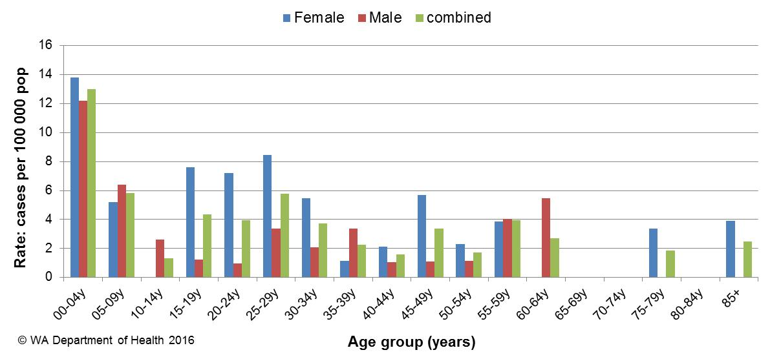

Figure 15. Age-specific notification rates for shigellosis by sex, WA, 2015

In 2015, the notification rate was 28 times higher for the Aboriginal population as compared to the non-Aboriginal population (57 and 2 per 100 000 population, respectively).

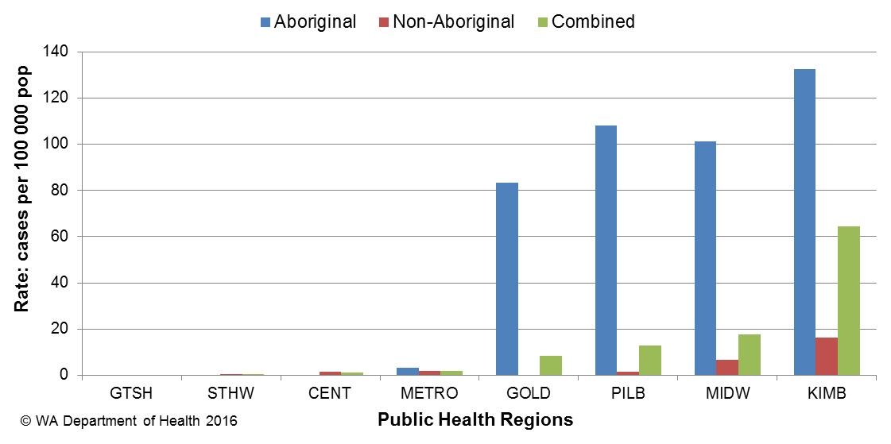

Figure 16. Shigellosis notification rates by region and Aboriginality, WA, 2015

In 2015, of the *Shigella* cases with known place of acquisition, 71% of all *Shigella* notifications were acquired in Western Australia (Figure 17). *Shigella sonnei* was the most common species (n=81, 84%), with *S. sonnei* biotype A the most common type (70%), which was also the type responsible for the outbreak among Aboriginal people. The second most common *Shigella* species was *S. flexneri* with 10 notifications (10%)*.*

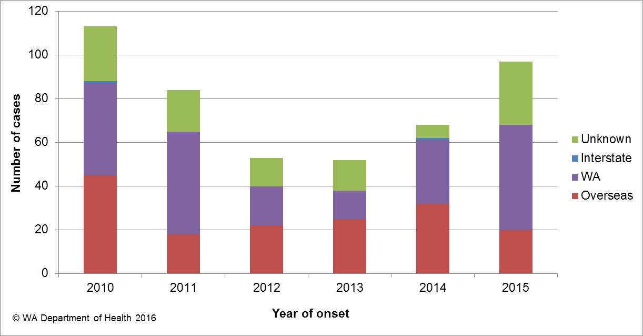

Figure 17. Place of acquisition for shigellosis cases, 2010 to 2015

# Hepatitis A virus infection

There were 25 cases of hepatitis A notified in 2015 with a rate of 1 case per 100 000 population, which is a 30% increase from the mean rate of the previous five years (Appendix 1).

The age range for the 2015 cases was 3 to 67 years and a median age of 22 years, with 15 males (60%) and 10 female (40%) notifications. Most (19, 76%) notifications in 2015 were acquired overseas (Figure 18) in 16 different countries.

There were six locally acquired cases including:

* 50 yo female with onset in February who was part of the national frozen berry (NFB) outbreak.
* 4 yo male with onset in March where the source of illness was unknown and the genetic sequence was different to the NFB.
* 22 yo female who was a possible secondary case to a known case who travelled overseas.
* 12 yo male and 38 yo male with onsets in October and December, respectively, and who both consumed frozen berries from a common supplier and had the same genetic sequence as the NFB (see 2015 4th quarter report).
* 24 yo male with onset in October who ate frozen berries frequently but the hepatitis strain could not be typed.

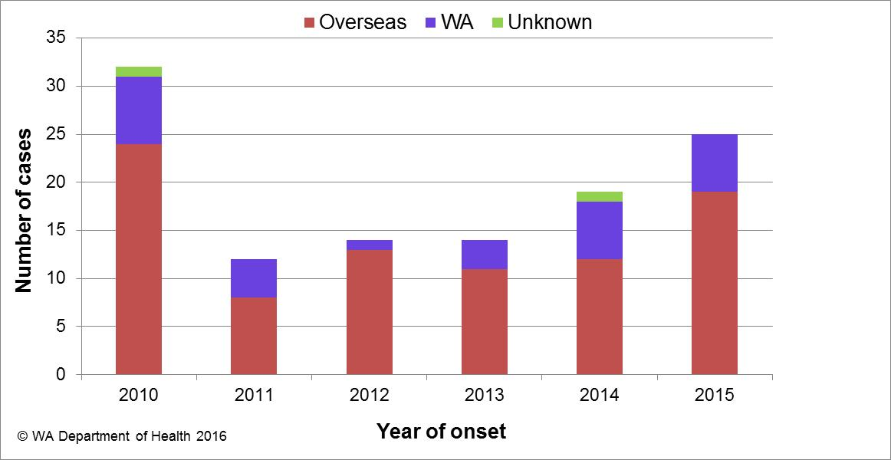

Figure 18. Place of acquisition for hepatitis A cases, 2010 to 2015

# Typhoid and paratyphoid fever

In 2015, there were nine reported cases of typhoid fever (caused by *Salmonella* Typhi) with a rate of 0.3 cases per 100,000 population, which was a 40% decrease compared to the mean rate of the previous five years (Appendix 1). All cases had recently travelled overseas prior to illness and countries included India (n=7), Indonesia (n=1) and Myanmar (n=1). Eleven cases of paratyphoid fever were notified in 2015 with a rate of 0.4 cases per 100,000 population, which was the same as the mean rate of the previous five years (Appendix 1). The paratyphoid fever cases included seven cases of *S*. ParatyphiA and four cases of *S*. Paratyphi B. All cases had overseas acquisition and countries included India (n=3), Indonesia (n=2), Bangladesh (n=2), Myanmar (n=2), Brazil (n=1) and Chile (n=1).

# Listeriosis

There were six cases of *Listeria monocytogenes* infection notified in 2015 which is similar to the mean rate of the previous five years (Appendix 1). Notifications comprised two perinatal and four non-pregnancy related cases (Figure 19). One non-pregnancy related case was overseas acquired. Two non-pregnancy cases did not have any immunocompromising illnesses, while the other two non-pregnancy cases reported regular use of immunosuppressive medications. One case died as a result of their infection. Cases ranged in age from <1 to 94 years, with three female and three males cases.

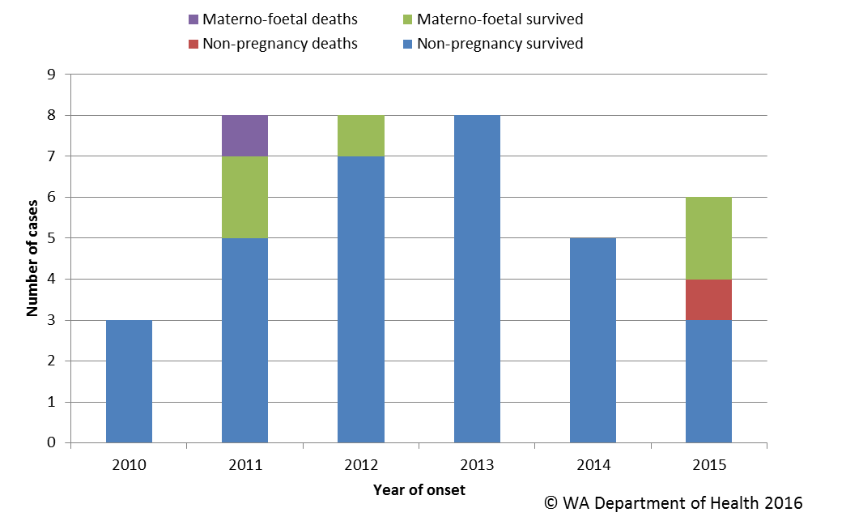

Figure 19. Notifications of listeriosis showing non-pregnancy related infections and deaths, and materno-foetal infections and deaths, WA, 2010 to 2015.

# *Vibrio parahaemolyticus* infection

There were seven cases of *Vibrio parahaemolyticus* infection in 2015 compared to the five year average of 14 cases per year. There were four male and three female cases, ranging in age from 15-89 years. Three cases reported travel overseas during their incubation period (to Indonesia, South America and Vietnam) and four cases acquired their illness in Western Australia. Of the locally acquired cases, three were marine associated wound infections.

# *Yersinia* infection

There were 32 cases of culture positive *Yersinia* *enterocolitica* infection notified in 2015, which is six times higher than the previous five year mean of five cases per year. There were 18 female and 14 male cases with ages ranging between <1 and 87 years. Six cases had acquired their infection overseas, 13 cases had acquired their illness in WA and place of acquisition was unknown for 13 cases. The majority of cases were notified by one private pathology laboratory, which uses a faecal PCR screening test, with reflex culture positive. Cases reported are culture positive.

# Haemolytic Uraemic Syndrome (HUS)

One case of HUS was notified in 2015 in a 12 year old female. Case presented to hospital with blood diarrhoea and vomiting. HUS was later diagnosed. Faecal specimens were negative for shiga toxin *E. coli* (STEC). Possible risk factors identified included contact with horses and beef consumption.

# Hepatitis E

There were two cases of hepatitis E notified in 2015. One case was a 52 year old male who acquired the infection in Bangladesh. The second case was a 6 year old male who acquired the infection locally.

# Botulism

One case of botulism was notified in 2015. A three month old female infant presented to hospital with poor feeding and floppiness. A faecal sample was positive for *Clostridium botulinum.* No obvious source of infection was identified.

# Cholera and STEC

There were no cases of cholera or STEC notified in WA in 2015.

# Gastrointestinal disease outbreaks and investigations

# Foodborne/probable foodborne outbreaks

There were 10 foodborne or probable foodborne gastroenteritis outbreaks investigated in WA in 2015 (Table 2). The 10 foodborne outbreaks caused at least 200 cases of gastroenteritis and 15 hospitalisations. Short descriptions of these outbreaks are described in 2015 quarterly reports. In the previous five years (2010 to 2014) there was an average of 12 (range 9-14) foodborne or probable foodborne outbreaks per year.

**Aetiology**

Of the 10 outbreaks, 7 outbreaks were due *Salmonella* Typhimurium (STM PFGE types 0001 x 5, 0003, 0013) and one outbreak each due to norovirus and hepatitis A. The pathogen was unknown for one outbreak as faecal specimens were not collected. The clinical symptoms, duration of illness and incubation period of this outbreak suggested it was due to toxin producing bacteria.

In the previous five years, *Salmonella* species caused most (n=24, 40%) outbreaks, followed by norovirus (n=10, 17%). *Clostridium perfringens* and *Campylobacter* species caused four outbreaks and two outbreaks, respectively; while single outbreaks were caused byhepatitis A, *Listeria monocytogenes* and *Cyclospora* species*.* Seventeen outbreaks were caused by unknown pathogens.

**Food vehicles**

The investigations of the 10 outbreaks identified food vehicles for nine outbreaks. The STM PFGE 0001 outbreaks were associated with consumption of egg dishes, or desserts containing raw eggs. The STM PFGE 0003 outbreak was associated with the consumption of raw eggs and raw egg mayonnaise, while the STM PFGE 0013 outbreak was associated with consumption of premade sandwiches. One outbreak each was associated with consumption of roast meats (suspected toxin mediated) and frozen berries (hepatitis A). The vehicle in the norovirus outbreak was unknown.

In the previous five years there were 60 foodborne or probable foodborne outbreaks and food vehicles were identified for 30 (50%) outbreaks. Of these 30 outbreaks, multiple foods were implicated in seven outbreaks, salads were implicated in five outbreaks, dishes containing eggs were implicated in four outbreaks, chicken in four outbreaks and other meat in three outbreaks. Single outbreaks were each caused by duck liver parfait, frozen meals, kava, lasagne, duck pancakes, assorted sandwiches and nasi lemak. Of the 30 outbreaks with unknown food vehicles, the aetiological agents included *Salmonella* (n=13), norovirus (n=3), *Campylobacter* (n=1), *Cyclospora* (n=1) and *Clostridium perfringens* (n=3) and unknown aetiology (n=9).

**Epidemiological investigation and evidence**

The evidence that supported that the 10 investigations of enteric outbreaks were due to foodborne or probable foodborne transmission was obtained using analytical studies for two outbreaks and descriptive cases series (DCS) for eight outbreaks. The analytical studies involved interviewing those people who were at the meal using a questionnaire on all foods/drinks available. These studies can be used to find a statistical association between a food eaten and illness and in 2015 an association was found in both outbreaks. For the outbreaks investigated as a DCS, there was strong circumstantial evidence to support probable foodborne transmission, such as independently visiting a common food business (eight outbreaks).

For the previous five years the evidence used to support that 60 outbreaks were due to foodborne transmission was obtained using analytical studies for 21 (35%) outbreaks and nine outbreaks found an association between illness and a food. There were 37 (62%) outbreaks investigated as DCS. No formal study was carried out for two outbreaks.

**Food preparation settings**

The setting where food was prepared for the 10 foodborne outbreaks in 2015, included three restaurants (caused by *S*. Typhimurium), one child care (*S*. Typhimurium), two commercial caterers (norovirusand unknown aetiology), two private residences (*S*. Typhimurium, hepatitis A), one takeaway (*S.* Typhimurium), and prisons (*S.* Typhimurium).

In the previous five years, the most common setting where food was prepared among the foodborne outbreaks was restaurants (n=24, 40%), followed by commercial caterers (n=7, 12%), aged care (n=7, 12%), private residence (n=6, 10%) and takeaway (n=4, 7%).

**Major factors for contamination of food**

The major contributing factor for case illness for outbreaks in 2015 was ingestion of contaminated raw products, where in four outbreaks people were thought to have ingested contaminated eggs and in one outbreak people were thought to have ingested contaminated frozen berries. No factors for the contamination of food could be identified for four of the 10 outbreaks in 2015.

The major factors for contamination of food in the 60 outbreaks in the previous five years were person to food to person transmission / food handler contamination (n=17, 28%). Of these 17 outbreaks, 10 were due to norovirus. There were six outbreaks where the contributing factor was ingestion of contaminated raw products and four of these outbreaks were due to *Salmonella*. Four outbreaks were thought to be caused by cross contamination with raw ingredients and all were due to *Salmonella*. There were 28 outbreaks with no identified contributing factor.

Table 2 Foodborne and probable foodborne outbreaks, 2015



^Month of outbreak is the month the outbreak was first report or investigated, whichever is earliest

*PT = phage type, PFGE=pulsed field gel electrophoresis

# D = descriptive, M= microbiological, A=Analytical

# Outbreaks due to non-foodborne transmission or with an unknown mode of transmission

In 2015, there were 142 outbreaks of gastroenteritis investigated that were not classified at foodborne disease outbreaks (Table 3). These outbreaks included 123 outbreaks associated with probable person-to-person transmission, two outbreak each due to probable waterborne transmission and 17 outbreaks were the mode of transmission was unclear or unknown (Figure 20).

**Probable person-to-person outbreaks**

Of the 123 probable as person-to-person (PTP) transmission, 71 (58%) occurred in residential care facilities, 33 (27%) in child care centres, 10 (8%) in hospitals, three (2%) in cruise ships, and one (1%) each at a camp, an institution, a military base, restaurant and school (Table 3). The causative agent for 54 (44%) of the outbreaks was confirmed as norovirus and eight (7%) outbreaks were due to rotavirus. In the remaining 60 outbreaks (49%) the causative agent was unknown, either because a pathogen was not identified during testing, specimens was not collected, or viral testing was not requested. A total of 2689 people were affected by these outbreaks, with 30 hospitalisations and 6 deaths.

The number of PTP outbreaks in 2015 was a 22% decrease on the number of outbreaks in 2014 (n=157), and 15% higher than the average of the previous five years (n=107). The long term season trend (2010 to 2015 data) for PTP outbreaks is that PTP outbreaks start to increase in September and peak in November (Figure 21).

**Outbreaks due to probable waterborne transmission**

There was two outbreaks were the likely transmission was waterborne. Detailed descriptions of these outbreaks are described in 2015 quarterly reports. One of these outbreaks was due to *S*. Typhimurium MLVA type 4-16-11-15-0, and associated with drinking contaminated drinking water at a holiday resort with 18 people becoming ill. The second outbreak was due to *Cryptosporidium* associated with swimming at a rural public pool with 12 people ill.

In the previous 10 years, there were four outbreaks were transmission was probable waterborne with three due to *Cryptosporidium* (in 2006, 2012 and 2014) and associated with swimming in rural public pools. The fourth outbreak was due to *Salmonella* Eastbourne (in 2013) associated with drinking bore water at a holiday resort.

**Outbreaks with unknown mode of transmission**

In the remaining 17 outbreaks the likely mode of transmission was unclear or unknown, with 13 (76%) occurring in aged care facilities, and one (6%) each at a hospital, a child care centre, an accommodation vessel and a private residence (Table 3). Below are descriptions of these outbreaks according to the site of the outbreak.

* There were 13 outbreaks in aged care facilities where the average percentage of cases with diarrhoea was 97% (range 82-100%) and average percentage of cases vomiting was 5% (range 0-25%). These symptoms are not norovirus-like and therefore described as unknown rather than person-to-person. Most of the outbreaks (11/13) had specimens tested which were negative for common bacterial and viral pathogens (including norovirus). Of these 11 outbreaks, two outbreaks also had specimens tested for *Clostridium perfringens* which were negative for this pathogen. No specimens were tested for two outbreaks.
* There were four other outbreaks in various setting where the transmission was unknown. One outbreak in a childcare centre had seven cases with diarrhoea and only one of these cases reported vomiting. No specimens were collected.

One outbreak in a hospital had five cases with diarrhoea and none of these cases reported vomiting. All specimens were negative for routine pathogens and viruses.

There were three cases of STM PFGE 57, MLVA 3-14-17-10-523 in an extended family. The first two cases lived together with onsets of illness one day apart and one of these cases did not eat feed as she was PEG fed. The son of one of the cases who lives in a separate house but visits them regularly had an onset nine days later. The mode of transmission was unknown.

One outbreak occurred on an accommodation vessel. The source was thought to be a temperature-abused food item served at a lunch but no specimens or samples collected and no study was conducted.

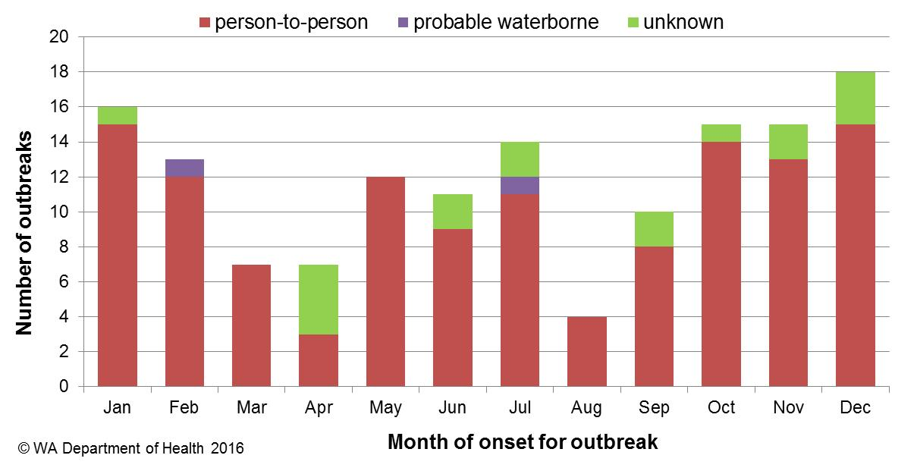

**Figure 20. Number of gastroenteritis outbreaks designated as non-foodborne or with unknown mode of transmission reported in WA, in 2015**

**Table 3. Outbreaks due to non-foodborne transmission or unknown mode of transmission in WA by setting and agent, 2015**



1 Deaths temporally associated with gastroenteritis, but contribution to death not specified

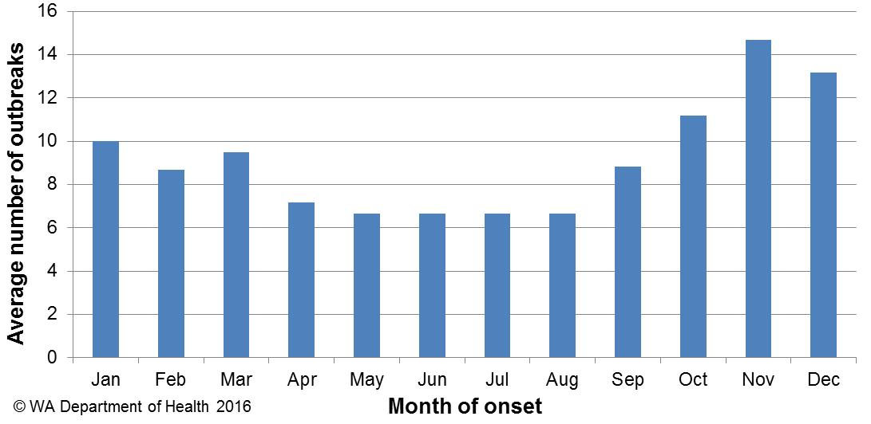

**Figure 21. Average number of gastroenteritis outbreaks due to person-to-person transmission for specific months for the period 2010 to 2015 in WA.**

# Cluster investigations

In 2015, there were five *Salmonella* clusters and one *Yersinia* cluster investigated (see Table 4) which are described in 2015 quarterly reports.

**Significant clusters**

*Salmonella* Typhimurium PFGE 0001

There has been an ongoing community-wide increase in notifications of STM PFGE 0001 (see figure 22) in WA since 2014. Further increases occurred in 2015 with 345 cases of PFGE type 0001 infection notified. In 2015, 30 confirmed cases (39 ill in total), were part of five point source outbreaks (see section 5) and the implicated foods were raw or undercooked eggs. The remaining 315 cases, comprising 48% males and 52% females, ranged in age from 1 to 90 years (average 30 years), and most (81%) resided in the Perth metropolitan area. Retail chicken meat sampled in September 2014 and an egg sample in October 2015 from a WA egg producer was also positive for PFGE type 0001. Previous interviews of sporadic cases (not in point source outbreaks) support the hypothesis that the cause of illness was consumption of free range eggs and/or chicken meat at home. From 25/2/15 onwards, non-outbreak cases have been investigated as part of a case-control study of STM PFGE 0001 illness, with 138 cases enrolled to date. The investigation is ongoing.

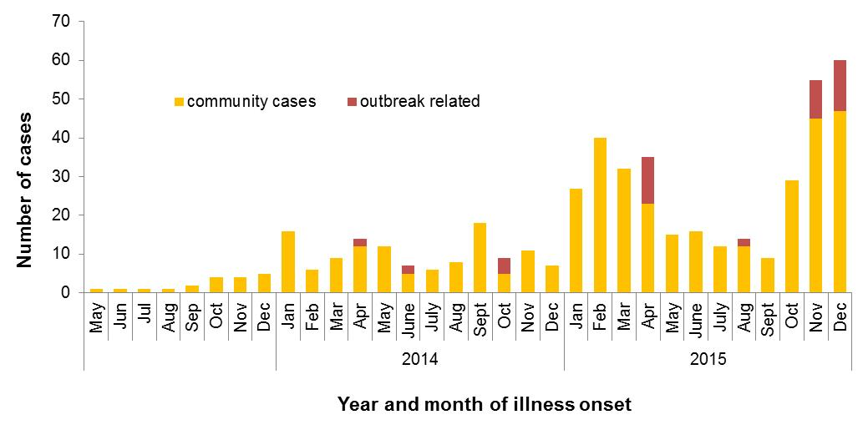Figure 22. Notifications of *Salmonella* Typhimurium PFGE 0001 in WA

***Salmonella* Kiambu**

A cluster of *S.* Kiambu cases was identified, with 18 cases reported in the first quarter of 2015 and 11 cases continuing into the second quarter of 2015. Onset dates were between 16/1/15 and 23/4/15, with 14 males and 15 females, ranging in age from <1 – 79 years (median age 8 years). Hypothesis-generating interviews were conducted with 14 cases. While no common venues were identified, all cases reported eating eggs in the incubation period and 71% (10/14 cases) reported eating raw or runny eggs during the incubation period. Egg consumption in cases was increased compared to historical *Salmonella* cases (72% egg consumption, 36% raw/runny egg consumption). No common brand of eggs was identified. Retail egg sampling of both caged and free range eggs was increased in response to this cluster, but no specimens were positive for *S*. Kiambu.

***Salmonella* Mbandaka**

A cluster of *S.* Mbandaka cases was identified, with 15 cases reported in March (n=11) and April (n=4). The historical five year average is one case/month. For the 15 cases, the average age was 38 years (range <1 years to 83), 33% were male and 67% female and apart from one case, all cases resided in metropolitan Perth. Hypothesis-generating interviews were conducted with eight cases. No common venues were identified, and no hypothesis for the cause of illness was identified.

***Salmonella* Typhimurium PFGE 0043**

An increase in STM PFGE 0043 was identified, with 13 cases reported in April (n=6) and May (n=7). The historical five year average for the same period is two cases. For the 13 case, 79% lived in metropolitan Perth, the average age was 32 years (range 7 year-79 years), with 54% male and 46% females. Five cases were interviewed and no hypothesis for the cause of illness could be established.

Table 4. Cluster investigations in WA by month investigation started, setting and agent, 2015



*PT = phage type, PFGE=pulsed field gel electrophoresis

# References

1. Hall G, Kirk MD, Becker N, Gregory JE, Unicomb L, Millard G, et al. Estimating foodborne gastroenteritis, Australia. Emerg Infect Dis 2005;11(8):1257-1264.
2. OzFoodNet Working Group. A health network to enhance the surveillance of foodborne diseases in Australia. Department of Health and Ageing 2013. <http://www.ozfoodnet.gov.au/>.
3. Western Australian Department of Health. A-Z list of case definitions. Western Australian Department of Health 2013. <http://ww2.health.wa.gov.au/Articles/N_R/Notification-of-infectious-diseases-and-related-conditions>.
4. National notifiable disease surveillance system. National case definitions. Department of Health and Ageing 2013. <http://www.health.gov.au/internet/main/publishing.nsf/Content/cda-surveil-nndss-nndssintro.htm>.
5. Western Australian Department of Health. Contact details for regional population / public health units. Western Australian Department of Health 2013. <http://healthywa.wa.gov.au/Articles/A_E/Contact-details-for-population-public-health-units> .

# Appendix 1: Number of notifications, notification rate and ratio of current to historical mean by pathogen/condition, 2010 to 2015, WA



1Abbreviations: STEC: Shiga-toxin producing *E. coli*; HUS: Haemolytic Uraemic Syndrome 2Rotavirus was made notifiable in July 2006 3Rate is cases per 100 000 population 4Mean of rates between 20010 and 2014 where applicable. NA: not applicable

This document can be made available in alternative formats on request for a person with a disability.

© Department of Health 2016