

This report describes enteric disease surveillance and investigations carried out during the first quarter of 2021 (1Q21) by OzFoodNet WA in conjunction with other Western Australian Department of Health agencies and local governments.

The increase in notifications for STEC and yersiniosis is partly attributed to the introduction of polymerase chain reaction (PCR) testing of faecal specimens, which has greater sensitivity than culture techniques. The decrease in other enteric notifications in 1Q21 is likely due COVID-19 public health measures including travel restrictions and possible improvements in hand hygiene in the general community.

**OzFoodNet Enteric Disease Surveillance Report 1st Quarter 2021**

**Enhancing foodborne disease surveillance across Australia**

1Q21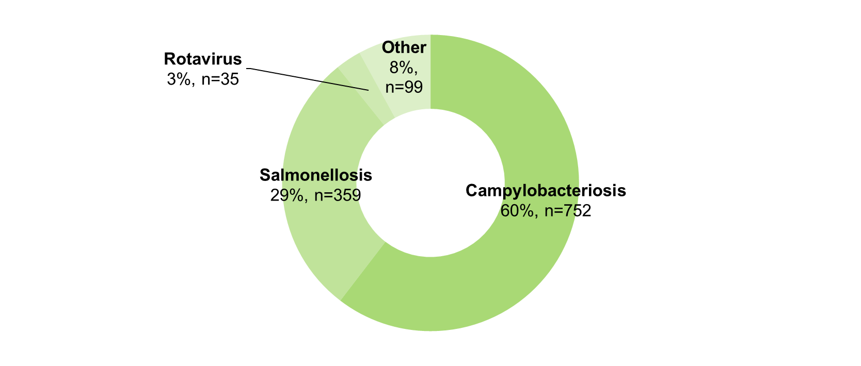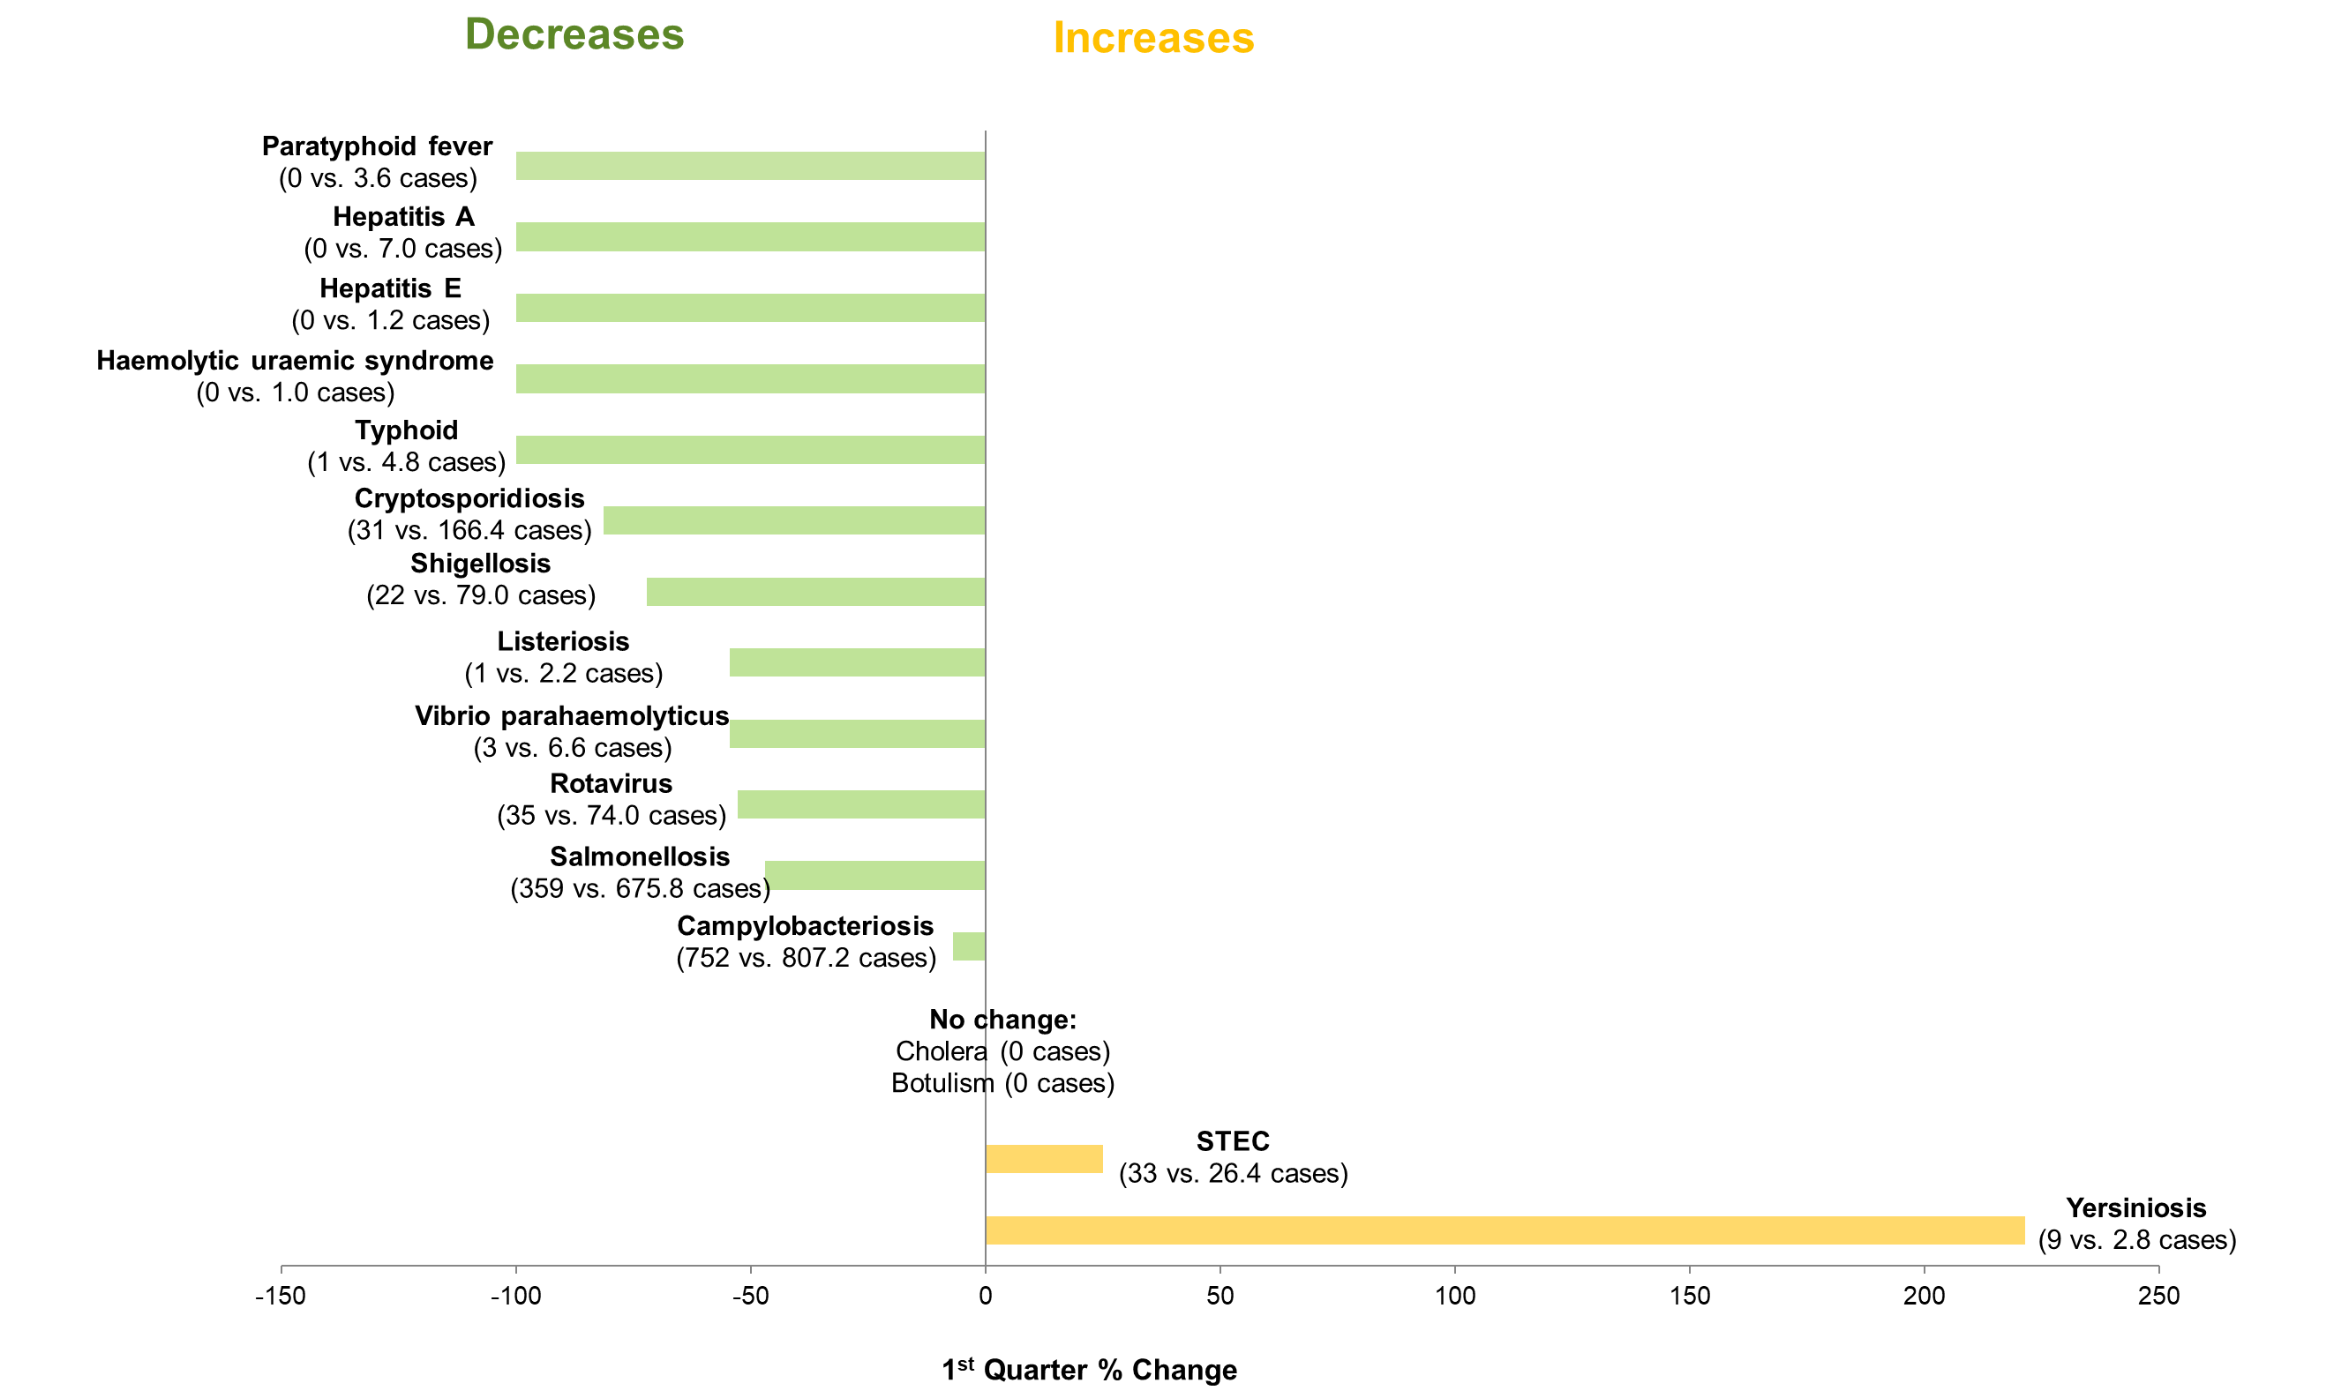

*Percentage change in the number of notifications in the current quarter compared to the historical 5-year mean for the same quarter. Positive values indicate an increase when compared to the historical 5-year mean of the same quarter. Negative values indicate a decrease when compared to the historical 5-year mean of the same quarter. Percentage change should be interpreted with caution when the number of cases is small.

**Most common enteric disease notifications in Quarter 1 2021**

**Change in enteric disease notifications (%)\***

**Appendix 1** Enteric diseases by public health region:

<https://ww2.health.wa.gov.au/~/media/Corp/Documents/Health-for/Infectious-disease/OZfoodnet/Word/WA-OzFoodnet-appendix1-2021-Q1.docx>

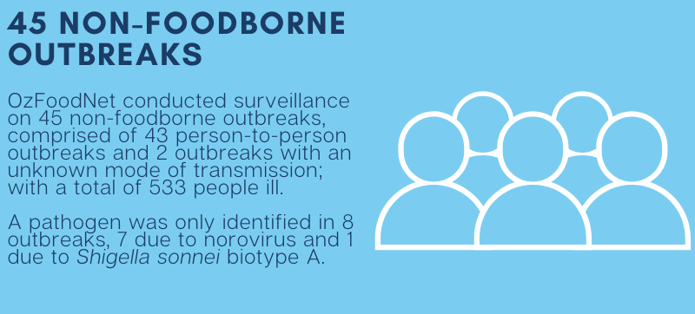**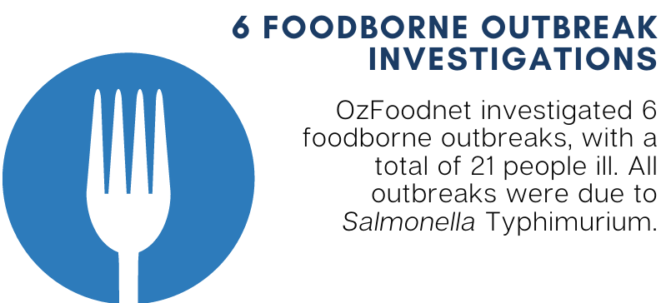Outbreaks in Quarter 1 2021**

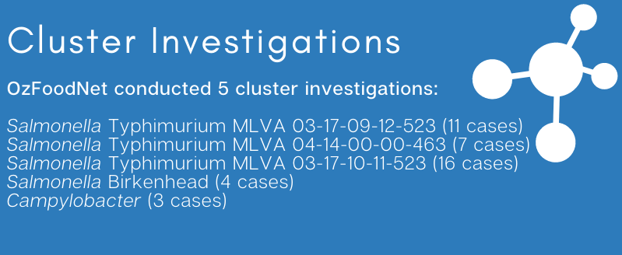

**Appendix 2** Details of foodborne outbreaks investigated in Quarter 1, 2021:

https://ww2.health.wa.gov.au/~/media/Corp/Documents/Health-for/Infectious-disease/OZfoodnet/Word/WA-OzFoodnet-appendix2-2021-Q1.docx

**Key trends from Quarter 1 2021**

***Salmonella* Typhimurium (STM) MLVA 03-17-09-12-523**

STM MLVA 03-17-09-12-523 has been under investigation since this type emerged in September 2016. From September 2016 to March 2021 there were 1934 cases notified, including 66 cases in 1Q21. This MLVA type was the single most common MLVA type notified in 1Q21, constituting 32% of STM notifications for the quarter. Of the 66 cases, 5 (8%) were part of two point-source outbreaks identified. The food vehicle was unknown in both outbreaks. Of the remaining 61 cases, most (89%) resided in the Perth metropolitan area. Hospitalisation status was ascertained for 57 community cases; 17.5% were hospitalised.



Figure: Notifications of *Salmonella* Typhimurium MLVA 03-17-09-12-523 in WA, September 2016 to March 2021

**Yersiniosis**

All nine notifications culture positive. Six were metropolitan residents. There were no point-source outbreaks.

**Shiga-toxin producing *E. coli* (STEC)**

Six of the 33 notifications were culture positive, all were the serotypes were O157:H7 (n=6). No point-source outbreaks were identified in 1Q21. Some of the increase is likely due to PCR testing of all faecal specimens by one private laboratory since the fourth quarter of 2018.

**Multi-drug resistant Shigella**

There were three notifications of *Shigella sonnei* Biotype G in 1Q21, these were alerted as multi-drug resistant. Two men were thought to have acquired their infection through male to male sexual contact.