Enteric disease surveillance and outbreak investigations in Western Australia 2021 annual report



**Enhancing foodborne disease surveillance across Australia**



OzFoodNet, Communicable Disease Control Directorate

**Acknowledgments**

Acknowledgement is given to the following people for their assistance with the activities described in this report: the staff from PathWest Laboratory Medicine WA; Mr Henry Tan and other staff from the Environmental Health Directorate of the Department of Health, Western Australia; Public Health Nurses from the metropolitan and regional Population Health Units; and Local Government Environmental Health Officers.

**Contributors/Editors**

Barry Combs, Stacey Hong, Stephania Tomlin, Benjamin Witham

Communicable Disease Control Directorate

Department of Health, Western Australia

PO Box 8172

Perth Business Centre

Western Australia 6849

Email: [OzfoodnetWA@health.wa.gov.au](mailto:OzfoodnetWA@health.wa.gov.au)

Telephone: (08) 9222 2131

Web:

OzFoodNet Department of Health, WA

<https://ww2.health.wa.gov.au/Articles/F_I/Infectious-disease-data/Enteric-infection-reports-and-publications-OzFoodNet>

OzFoodNet Department of Health and Ageing

<https://www1.health.gov.au/internet/main/publishing.nsf/Content/cdna-ozfoodnet.htm>

**Disclaimer**:

Every endeavour has been made to ensure that the information provided in this document was accurate at the time of writing. However, infectious disease notification data are continuously updated and subject to change.

PUBLISHED BY

This publication has been produced by the **Department of Health, Western Australia**.

# Executive summary

This report is a summary of enteric disease surveillance activities and outbreak investigations in Western Australia (WA) in 2021. Enteric disease causes a large burden of illness in the WA community. In WA, there are 15 enteric infections and one enteric disease-related condition that are notifiable to the Department of Health. The Department of Health through OzFoodNet (OFN) and other agencies conducts surveillance and investigates outbreaks so that targeted interventions can be used to help prevent further transmission.

In 2021, there were 5237 notifications of enteric disease in WA, which was a rate of 197 per 100 000 population. The 2021 rate was 12% lower than the mean rate for the previous five years. The age group with the highest enteric disease rate was 0-4 years with 586 cases per 100 000 population. The rate of enteric disease for Aboriginal people was 63% higher than for non-Aboriginal people. Of the notified enteric infections with a known place of acquisition, 99.5% reported acquiring their infection in WA, <1% reported overseas travel and <1% reported interstate travel.

As with previous years, campylobacteriosiswas the most commonly notified enteric disease in 2021 (n=3153; 60%) followed by salmonellosis (n=926; 18%); notification rates are 11% higher and 48% lower than the previous five-year average, respectively. Most notifiable enteric diseases in 2021 had lower or comparable rates to the previous five-year average. Some of the decrease in 2021 may be due to overseas and interstate travel restrictions and social distancing measures as a result of the COVID-19 pandemic. Notable increases were observed for rotavirus (n=733, 2.5 fold increase), *Yersinia* (n=38, 2.8 fold increase) and *Vibrio parahaemolyticus* (n=39, 2.9 fold increase).

**Foodborne and probable foodborne outbreaks**

In 2021, there were 21 outbreaks of foodborne or probable foodborne disease investigated in WA that caused at least 172 cases of illness. Of these 21 outbreaks, 12 were caused by *Salmonella* Typhimurium, two outbreaks were due to *Campylobacter*, one each due to *Clostridium perfringens*, norovirus, *Salmonella* Infantis, *Salmonella* Saintpaul, shiga-toxin producing *E. coli, Vibrio parahaemolyticus* and for one outbreak the aetiology was unknown (Table B).

Of these 21 outbreaks, a food vehicle was identified in 52% (n=11). Raw or undercooked egg and egg-containing dishes were the most commonly implicated food (n=4, 19%).

**Table A: Foodborne outbreaks investigated in WA by aetiology, 2021**

**Non-foodborne enteric disease outbreaks**

Non-foodborne enteric disease outbreaks and outbreaks with an unknown mode of transmission are a major cause of illness, especially in institutions such as residential care facilities (RCFs) and child care centres (CCCs). There were 262 non-foodborne outbreaks reported in 2021 which resulted in 3812 ill people, 34 hospitalisations and 1 associated death. Most of these outbreaks were in RCFs and CCCs and due to person-to-person transmission. There was a large increase in outbreaks at CCCs in 2021, most reported in the fourth quarter and in the Perth metropolitan region.

# Table of contents

Executive summary 3

Table of contents 5

Introduction 7

Data sources and methods 9

Data sources 9

Data collection by Aboriginality 10

Regional boundaries 10

Calculation of rates 10

Definitions 11

Site activities during the year 11

Surveillance and investigation 11

Activities on enhancing laboratory and epidemiological surveillance 12

Activities to assist enteric disease policy development 12

Strengthening skills and capacity for enteric disease surveillance and investigation 13

Conference meetings and presentations 13

Incidence of specific enteric diseases 13

Botulism 14

Campylobacteriosis 14

Cholera 16

Cryptosporidiosis 16

Haemolytic Uraemic Syndrome (HUS) 18

Hepatitis A infection 18

Hepatitis E infection 19

Listeriosis 19

Rotavirus infection 20

Salmonellosis 22

Shiga toxin-producing *E. coli* (STEC) infection 26

Shigellosis 28

Typhoid and paratyphoid fever 30

*Vibrio parahaemolyticus* infection 30

*Yersinia* infection 31

Gastrointestinal disease outbreaks and investigations 31

Foodborne and probable foodborne outbreaks 31

Outbreaks due to non-foodborne transmission or with an unknown mode of transmission 35

Cluster investigations 37

References 40

Appendix 1: Number of notifications, notification rate2 and ratio of current to historical mean by pathogen/condition, 2016 to 2021, WA 41

List of tables

Table 1 Number and proportion of the top 10 *Salmonella* serotypes notified in WA, 2021, with comparison to the 5-year average 25

Table 2 The 10 most common *S*. Typhimurium MLVA types reported in 2021 26

Table 3 Foodborne and probable foodborne outbreaks, 2021 34

**Table 4 Outbreaks due to non-foodborne or unknown mode of transmission in WA by setting and agent, 2021** 37

**Table 5 New cluster investigations in WA by month investigation started, setting and agent, 2021** 38

List of figures

Figure 1 Campylobacteriosis notifications by year and month, WA, 2016 to 2021 14

Figure 2 Campylobacteriosis notification rate by age group and sex, WA, 2021 15

Figure 3 Campylobacteriosis notification rates by region and Aboriginality, WA, 2021 16

Figure 4 Cryptosporidiosis notifications by year and month, WA, 2016 to 2021 17

Figure 5 Cryptosporidiosis notification rate by age group and sex, WA, 2021 17

Figure 6 Cryptosporidiosis notification rates by region and Aboriginality, WA, 2021 18

Figure 7 Place of acquisition for hepatitis A notifications, 2016 to 2021 19

Figure 8 Notifications of listeriosis showing non-pregnancy related infections and deaths, and materno-foetal infections and deaths, WA, 2016 to 2021 20

Figure 9 Rotavirus notifications by year and month, WA, 2015 to 2020 20

Figure 10 Rotavirus notification rates by age group and sex, WA, 2021 21

Figure 11 Rotavirus notification rates by region and Aboriginality, WA, 2021 22

Figure 12 Salmonellosis notifications by year and month, WA, 2016 to 2021 22

Figure 13 Salmonellosis notification rate by age group and sex, WA, 2021 23

Figure 14 Salmonellosis notification rates by region and Aboriginality, WA, 2021 24

Figure 15 Salmonellosis notifications by place of acquisition and year, 2016 to 2021 24

Figure 16 STEC notifications by year and month, WA, 2016 to 2021 27

Figure 17 STEC notification rates by age group and sex, WA, 2021 27

Figure 18 Shigellosis notifications by year and month, WA, 2016 to 2021 29

Figure 19 Shigellosis notification rates by age group and sex, WA, 2020 29

Figure 20 Shigellosis notification rates by region and Aboriginality, WA, 2021 30

Figure 21 Number of non-foodborne gastroenteritis outbreaks by mode of transmission and month, 2021 36

Figure 22 Notifications of *Salmonella* Typhimurium MLVA 03-17-09-12-523 in WA 39

# Introduction

It has been estimated that there are 5.4 million cases of foodborne illness in Australia each year and that the cost of this illness is $1.2 billion per year1. This is likely to be an underestimate of the true cost of enteric illness in Australia as not all enteric infections are caused by foodborne transmission. Other modes of transmission such as person-to-person, animal-to-person and waterborne transmission are also very important in enteric infection. Most enteric infections are preventable through interventions at the level of primary production, institution infection control, and food handling and hand hygiene at food businesses and in households.

This report describes Western Australian enteric disease surveillance and investigations carried out in 2021 by OzFoodNet WA (OFN) and other Western Australian government agencies. Most of the data presented in this report is derived from enteric disease notifications from doctors and laboratories received by the Department of Health, WA and are likely to underestimate the true incidence of disease. This data nevertheless remains the most important information on incidence of these infections for surveillance purposes in Western Australia (WA). In addition, norovirus, which is not notifiable, is the cause of a large burden of illness in RCFs and in the general community.

OFN is part of the Communicable Disease Control Directorate (CDCD) of the WA Department of Health. OFN in WA is also part of a National OzFoodNet network funded by the Commonwealth Department of Health2. The mission of OzFoodNet is to enhance surveillance of foodborne illness in Australia and to conduct applied research into associated risk factors. The OFN site based in Perth is responsible for the whole of WA, which has a total population of approximately 2.6 million. Collaboration between States and Territories is facilitated by circulation of fortnightly jurisdictional enteric surveillance reports, monthly teleconferences, tri-annual face-to-face meetings and through the informal network. This network also includes communication and consultation with Food Standards Australia New Zealand, the Commonwealth Department of Health, the National Centre for Epidemiology and Population Health, the Communicable Diseases Network of Australia and the Public Health Laboratory Network.

The primary objectives of OzFoodNet nationally are to:

* estimate the incidence and cost of foodborne illness in Australia,
* investigate the epidemiology of foodborne diseases, by enhancing surveillance and conducting studies on foodborne pathogens,
* collaborate nationally to coordinate investigations into foodborne disease outbreaks, particularly those that cross State, Territory and country borders,
* train people to investigate foodborne illness.

At a local level, OFN conducts surveillance of enteric infections to identify clusters and outbreaks of specific diseases and conducts epidemiological investigations to help determine the cause of outbreaks. OFN also conducts research into the risk factors for sporadic cases of enteric diseases and develops policies and guidelines related to enteric disease surveillance, investigation and control. OFN regularly liaises with staff from the Population Health Units (PHUs), the Environmental Health Directorate of Department of Health, WA (EHD); and the Environmental, Diagnostic and Surveillance laboratories at PathWest Laboratory Medicine WA (PathWest).

CDCD maintains and coordinates the WA notifiable disease surveillance system and provides specialist clinical, public health and epidemiological training and advice to PHUs. The WA notifiable diseases surveillance system relies on the mandatory reporting by doctors and laboratories of notifiable diseases and disease-related conditions, 16 of which are enteric.

PHUs are responsible for public health activities, which includes communicable disease control, in their WA administrative health regions. There are eight PHUs in WA that are involved with communicable disease surveillance: Goldfields, Great Southern, Kimberley, Metropolitan, Midwest, Pilbara, South West and Wheatbelt. The PHUs monitor facility gastroenteritis outbreaks and provide infection control advice. The PHUs also conduct follow up of single cases of important enteric diseases including typhoid, paratyphoid, hepatitis A and E, cholera and *Shigella dysenteriae*. OFN will also assist with the investigation of these enteric diseases if there is a cluster and/or they are locally acquired, and will investigate facility outbreaks if the outbreak is due to probable foodborne transmission.

The EHD liaises with Local Government (LG) Environmental Health Officers (EHOs) during the investigation of food businesses, and coordinates food business investigations when multiple LGs are involved.

The Environmental, Diagnostic and Surveillance laboratories at PathWest provide public health laboratory services for the surveillance and investigation of enteric disease.

# Data sources and methods

### **Data sources**

Data on WA cases of notifiable enteric diseases were obtained from the WA notifiable infectious disease database (WANIDD). The notifications contained in WANIDD are received from medical practitioners and pathology laboratories under the provisions of the Public Health Act 2016 and subsequent amendments, and are retained in WANIDD if WA (for diseases not nationally notifiable)3 or national case definitions are met4.

Notifiable enteric diseases included in this report are botulism, campylobacteriosis, cholera, cryptosporidiosis, haemolytic uraemic syndrome (HUS), hepatitis A infection, hepatitis E infection, listeriosis, rotavirus infection, salmonellosis, shiga toxin-producing *E. coli* (STEC) infection, shigellosis, typhoid and paratyphoid fever, *Vibrio parahaemolyticus* infection and yersiniosis. In March 2022, data for these diseases were extracted from WANIDD by optimal date of onset (ODOO) for the time period 01/01/2016 to 31/12/2021, and exported to Microsoft® Excel 365. The ODOO is a composite of the ‘true’ date of onset provided by the notifying doctor or obtained during case follow-up, the date of specimen collection for laboratory notified cases, and when neither of these dates is available, the date of notification by the doctor or laboratory, or the date of receipt of notification, whichever is earliest.

Notification data extracted for this report may have been revised since the time of extraction. Subsequent minor changes to the data would not substantially affect the overall trends and patterns.

Information on *Salmonella* serotypes, *Shigella* species, Multi-locus variable number tandem repeat analysis (MLVA) and whole genome sequencing (WGS) of certain pathogens was obtained from PathWest, the reference laboratory for WA. Other specialised diagnostic data were obtained from the Microbiological Diagnostic Unit, University of Melbourne and the Australian *Salmonella* Reference Laboratory, Institute of Medical and Veterinary Science (Adelaide).

Information on RCF and other facility outbreaks was collected by PHU staff who forward collated epidemiological and laboratory data to OFN.

### **Data collection by Aboriginality**

For the purposes of this report, the term ‘Aboriginal’ is used in preference to ‘Aboriginal and Torres Strait Islander’ to recognise that Aboriginal people are the original inhabitants of WA.

In WA, there is considerable mobility of Aboriginal people, both within WA and across the Northern Territory and South Australia borders, which means that some Aboriginal people will be patients of more than one health service. Due to the small size of the Aboriginal population in WA (4% of the total population in 2020) and the large number of cases reported in Aboriginal people, inaccuracies in the population estimates of Aboriginal people can have a disproportionate impact on calculated rates. In the preparation of this report, these factors are acknowledged as limitations. Information on Aboriginality is also missing for 3% of enteric notifications in 2021.

### **Regional boundaries**

Notification data is divided into ten WA Health administrative regions based on PHU boundaries. Three of the regions are in the Perth metropolitan area (East, North and South) and seven in the regional areas are Goldfields (GOLD), Great Southern (GSTH), Kimberley (KIMB), Midwest (MIDW), Pilbara (PILB), South West (STHW) and Wheatbelt (CENT). For the purposes of this report, the three metropolitan PHUs have been combined into one ‘metropolitan’ (METRO) region.

### **Calculation of rates**

Notification rates were calculated by dividing the number of notifications of infections within the relevant population by the total number of people within that population and were expressed per 100,000 population. WA’s estimated population denominators used for calculation of rates were obtained from Rates Calculator version 9.5.5.1 (Epidemiology Branch, WA Department of Health). The Rates Calculator provides population estimates by age, sex, Aboriginality, year and area of residence, and is based on population figures based upon 2016 Australian Bureau of Statistics Census data. Rates calculated for this report have not been adjusted for age. It should be noted that small numbers of notifications give unstable and imprecise notification rates.

### **Definitions**

**Foodborne outbreak** is an incident where two or more persons experience a similar illness after consuming a common food or meal and epidemiological analyses and/or microbiological evidence (including food and/or environmental) implicates the meal or food as the source of illness; or the aetiology of the outbreak can only result through foodborne transmission (e.g. *Listeria monocytogenes* infection, ciguatera fish poisoning).

**Probable foodborne outbreak** is an incident where two or more persons experience a similar illness after consuming a common food or meal and compelling descriptive epidemiological evidence implicates the meal or food as the suspected source of illness. This includes outbreaks where the mode of transmission is suspected to be from an ill food handler to food to person.

**Probable person-to-person outbreak** is an incident where two or more persons develop gastrointestinal symptoms following exposure to a person or group of people, either known or suspected to be infectious, or an environment where an infected person has been known to have contaminated and onset dates of illness suggest ongoing transmission.

**Unknown outbreak transmission** is an incident where two or more persons experience a similar illness but the mode of transmission is unable to be determined.

**Salmonella outbreak due to an egg dish** is nominated as the implicated food if

* *Salmonella* is isolated from eggs (from the implicated premises) or from the implicated dish containing eggs (microbiological evidence) OR
* There is analytical evidence that a dish containing eggs was associated with illness OR
* In the absence of microbiological or analytical evidence, an implicated dish is described as an egg dish if it contains raw or undercooked eggs and most cases report eating the dish in the absence of other high risk foods eaten in common.

# Site activities during the year

During 2021 the following activities and prevention measures were conducted by OFN.

### **Surveillance and investigation**

* Ongoing surveillance of infectious enteric disease in WA.
* Investigation of 21 local foodborne or probable foodborne outbreaks and eight clusters.
* Investigation of seven *Listeria* *monocytogenes* cases.
* Surveillance of one typhoid case.
* Investigation of *S.* Enteritidis cases with unknown travel history and interviews of 10 locally acquired cases with a hypothesis generating questionnaire to identify risk factors for the cause of illness.
* Surveillance of 246 person-to-person gastroenteritis outbreaks, including 70 that occurred in RCFs and 159 in child care centres.
* Investigation of 14 gastroenteritis outbreaks with unknown mode of transmission, seven of which occurred at RCFs.
* Investigation of one probable waterborne outbreak due to *S*. Adelaide.
* Investigation of one probable zoonotic outbreak due to *Cryptosporidium*.
* Investigation of 107 cases of STEC and interview of acute cases to identify risk factors for the cause of illness.
* Participation in multi-jurisdictional outbreak investigations.

### **Activities on enhancing laboratory and epidemiological surveillance**

* Participation in fortnightly meetings with EHD staff.
* Provision of enteric disease data, interpretation and advice upon request to LG EHOs, laboratory and PHU staff.
* Participation in monthly national OzFoodNet teleconferences.
* Monitoring of culture-independent nucleic acid amplification diagnostic testing in private and public laboratories and impact on notification rates.
* Addition of illness and exposure data for WA *Listeria monocytogenes* and hepatitis A cases to national enhanced data sets.
* Participation in the WA *Salmonella* Outbreak Response Taskforce activities, which included survey of eggs and egg producers as well as whole genome sequencing and analysis of human and non-human isolates.
* Participation in a rotavirus project with the Murdoch Children’s Research Institute on the molecular typing of rotavirus samples.
* Developing a REDCap notification tool for facilities to report gastroenteritis outbreaks.
* Provided reports on the emergent MDR *Shigella* to the WAMRO (Western Australia Multi-resistant Organism) expert advisory committee.

### **Activities to assist enteric disease policy development**

* Participation in the WA Foodborne Illness Reduction Strategy Across-Government Advisory Group and Primary Production and Processing Project Group.
* Progress of reviewing and transitioning operational directives related to sporadic enteric disease follow up, enteric disease exclusions and the management and reporting of gastroenteritis outbreaks in facilities.
* Developed and published guidelines for the [treatment of shigellosis in WA](https://ww2.health.wa.gov.au/~/media/Corp/Documents/Health-for/Communicable-Diseases/Guidelines/Treatment-for-Shigella-infections-in-Western-Australia.pdf).

### **Strengthening skills and capacity for enteric disease surveillance and investigation**

* Developed content in July for university lecture material on enteric disease outbreak investigations.
* Presented in September to PathWest laboratory staff on OzFoodNet WA activities.
* Presented in May to Public Health registrars on the process for surveillance of outbreaks and investigations.
* Gave a presentation in August to University Masters students on foodborne illness.

### **Conference meetings and presentations**

* Presented an enteric disease update at the Public Health Nurses seminar in December.

# Incidence of specific enteric diseases

In 2021, a total 5237 notifications of enteric disease were reported in WA, which was a rate of 197 per 100 000 population. This rate was 12% lower than the mean rate for the previous five years of 247 per 100 000 population. The overall rate was heavily influenced by notifications of campylobacteriosis and salmonellosis which comprised 60% and 18% of reports, respectively. The age group with the highest enteric disease rate was 0-4 years with 586 cases per 100 000 population, which is three times the overall rate for WA. In 2021, Aboriginal people had a rate of 304 cases per 100 000 population which was 63% higher than non-Aboriginal people (187 cases per 100 000 population). The age group with the highest rate among Aboriginal people was 0-4 years with a rate of 1460 cases per 100 000 population, compared to a 0-4 year age group rate for non-Aboriginal people of 505 cases per 100 000 population. The region with the highest rate was the Kimberley region with 701 cases per 100 000 population. Of the people notified with enteric infections with a known place of acquisition, 99.5% reported acquiring their infection in WA, <1% reported overseas travel and < 1% reported interstate travel. Some of the decrease in enteric notifications in 2021 is likely a result of the decline in overseas acquired infections following travel restrictions from March onwards as a result of the COVID-19 pandemic. In the 2016-2020 period, an average of 22% of enteric notification with a place of known acquisition were acquired overseas.

### Botulism

Botulism is rare in WA, with the last case reported in 2015.

### Campylobacteriosis

Campylobacteriosis was the most commonly notified enteric infection in 2021 with 3153 notifications and a rate of 118.9 per 100 000 population. This notification rate was 8% lower than the previous five-year average (Appendix 1), which is likely due to the overseas travel restrictions due to the COVID-19 pandemic. Campylobacteriosis notifications were lowest in May are historically highest in the spring and summer months, which also occurred in 2021 (Figure 1). In 2021, as with previous years, the campylobacteriosis notification rate for males was higher than for females (135.1 and 102.7 per 100 000 population, respectively). The highest rates were in adults 75-79 years and 80-84 years (172.1-181.8 per 100 000 population respectively) followed by young children 0-4 years (171.9 per 100 000 population) (Figure 2). The lowest rates were in the age groups 10-14 years (70.1 per 100 000 population) and 5-9 years (85.3 per 100 000 population).

Figure 1 Campylobacteriosis notifications by year and month, WA, 2016 to 2021



Figure 2 Campylobacteriosis notification rate by age group and sex, WA, 2021



For the last six years the notification rate for non-Aboriginal people has been consistently higher than for Aboriginal people and for 2021, the rate for non-Aboriginal people was 2.1 times higher (117.9 and 57.0 per 100 000 population, respectively). The 2021 notification rate for campylobacteriosis was highest in the Great Southern region (174.5 cases per 100 000 population). The region with the lowest rate was the Kimberley region (94.8 per 100 000 population) (Figure 3). Of those campylobacteriosis cases with known place of acquisition, most (99.6%) people acquired their illness in WA with no people acquiring their illness overseas. There were seven (0.4%) notifications who acquired their illness interstate.

Figure 3 Campylobacteriosis notification rates by region and Aboriginality, WA, 2021



### Cholera

Cholera is mainly seen in people who have travelled overseas. The last case in WA was in 2017.

### Cryptosporidiosis

There were 131 cryptosporidiosis cases notified in 2021, making it the fourth most common notifiable enteric disease. The notification rate (4.9 cases per 100 000 population) which is 56% less than the mean of the previous five years (11.3 cases per 100 000 population) (Appendix 1). In each of the years from 2016 to 2021, the number of cryptosporidiosis notifications tended to increase in the late summer through to autumn (Figure 4). In 2021, there was no clustering of cases by postcode identified, that may have indicated water-borne transmission. There were two cases of cryptosporidiosis who were university students and had attended the same dairy farm as part of their practical. They became ill while at the farm or within one day of leaving the farm. Zoonotic transmission of cryptosporidiosis has been reported in Australia5.

Figure 4 Cryptosporidiosis notifications by year and month, WA, 2016 to 2021



The cryptosporidiosis notification rate in females was similar to males in 2021 (5.0 and 4.9 per 100 000 population, respectively). The 0-4 years age group had the highest notification rate (24.6 per 100 000 population) and accounted for 33% of all cryptosporidiosis notifications (Figure 5).

Figure 5 Cryptosporidiosis notification rate by age group and sex, WA, 2021



The overall notification rate for the Aboriginal population was seven-fold higher than the rate for the non-Aboriginal population (27.1 and 3.7 cases per 100 000 population, respectively). The Kimberley region had the highest notification rate (109 cases per 100 000 population), followed by the Great Southern region (13 cases per 100 000 population) (Figure 6). Of those cryptosporidiosis cases with known place of acquisition, all acquired their illness in WA.

Figure 6 Cryptosporidiosis notification rates by region and Aboriginality, WA, 2021



### Haemolytic Uraemic Syndrome (HUS)

Two cases of HUS were notified in 2021, which is the same as the five-year historic mean of two cases. Cases were two males, aged 2 and 3 years. One case had acute gastroenteritis and diagnosed with STEC and the other case was diagnosed with invasive *Streptococcus pneumoniae*. The case diagnosed with STEC had visited their grandparents farm twice for 8-12 hrs each time during their incubation period. The farm had 100-200 cows with calves, but the case has no direct contact with cows.

### Hepatitis A infection

There was a single case of hepatitis A notified in 2021 with a rate of 0.04 cases per 100 000 population compared to the average rate of the previous five years of 0.5 cases per 100 000 population (Appendix 1). The case was an 18 year old female who had returned from Pakistan. The decrease in 2021 was likely due to overseas travel restrictions.

Figure 7 Place of acquisition for hepatitis A notifications, 2016 to 2021



### Hepatitis E infection

There were no cases of hepatitis E notified in 2021 compared to the five year average of three cases.

### Listeriosis

There were six cases of *Listeria monocytogenes* infection notified in 2021 with a rate of 0.2 cases per 100 000 population, which was similar to the average rate of the previous five years (Appendix 1). There were no materno-foetal pairs in 2021 (Figure 8). The six cases had immunocompromising illnesses, ages ranged from 35 to 84 years with four males and two female cases. One death was temporally reported in a 83 year old case.

Figure 8 Notifications of listeriosis showing non-pregnancy related infections and deaths, and materno-foetal infections and deaths, WA, 2016 to 2021



### Rotavirus infection

There were 733 cases of rotavirus infection in WA in 2021 with a rate of 27.6 per 100 000 population, which was 2.5 fold higher than the previous five-year average of 11.3 cases per 100 000 population (Appendix 1). Historically, rotavirus notifications typically peak in the winter months, but in 2021 cases increased substantially from September to December with 571 notifications reported (Figure 9).

Figure 9 Rotavirus notifications by year and month, WA, 2015 to 2020



As in previous years, the age group with the highest rotavirus notification rate in 2021 was the 0-4 years group (214.1 cases per 100 000 population) (Figure 10). The overall notification rate was similar for females and males (29.1 and 26.1 per 100 000 population, respectively).

Figure 10 Rotavirus notification rates by age group and sex, WA, 2021



The regions with the highest rotavirus notification rates in 2021 were the Kimberley and Pilbara regions (195.3 and 62 cases per 100 000 population, respectively) (Figure 11). Overall, notification rates were 4 times higher for Aboriginal than for non-Aboriginal people (92.4 and 23.9 per 100 000 population, respectively). Of those rotavirus cases with known place of acquisition, 99% of cases acquired their illness in WA with the remaining 1% of cases acquiring their illness interstate. There were 10 person-to-person outbreaks due to rotavirus in 2021 at residential care facilities (n=5), at childcare centres (n=3), at a school (n=1) and an outbreak in a Kimberley Aboriginal community.

Figure 11 Rotavirus notification rates by region and Aboriginality, WA, 2021



### Salmonellosis

Salmonellosis was the second most commonly notified enteric infection in WA in 2021 with 926 cases and rate of 34.9 cases per 100 000 population (Appendix 1), which was 57% lower than the previous five-year average (81.0 cases per 100 000 population). Historically, salmonellosis notifications are highest in the summer and autumn months, but the peak for salmonellosis in 2021 was in March (Figure 12).

Figure 12 Salmonellosis notifications by year and month, WA, 2016 to 2021



The notification rate for males was marginally higher than for females (35.8 and 34.1 per 100 000 population, respectively). As in previous years, the 0-4 year age group had the highest notification rate (153 per 100 000 population) (Figure 13). The age group 05-09 years had the next highest notification rate (39.5 per 100 000 population).

Figure 13 Salmonellosis notification rate by age group and sex, WA, 2021



The salmonellosis notification rate for Aboriginal people was 74.7 cases per 100 000 population, which was 2.3 times higher than the notification rate for non-Aboriginal people (32.4 cases per 100 000 population).

The Kimberley region had the highest notification rate in 2021 (212.5 per 100 000 population) which was 9.3 times the rate for the Great Southern region, which had the lowest notification rate, of 22.8 cases per 100 000 population (Figure 14). The notifications in the Kimberley region include 40 different serotypes and did not cluster in time or location.

Of those salmonellosis cases with known place of acquisition (80%), most (99%) cases acquired their illness in WA with <1% of cases acquiring their illness interstate (Figure 15).

Figure 14 Salmonellosis notification rates by region and Aboriginality, WA, 2021



Figure 15 Salmonellosis notifications by place of acquisition and year, 2016 to 2021



The most commonly notified *Salmonella* serotype in WA in 2021 was *S.* Typhimurium (STM), with 469 notifications (Table 1), which was 51% of all *Salmonella* and 48% lower than the mean of the previous five years for STM. STM is further typed using MLVA and there were 139 MLVA types identified in 2021. Of these, the top 10 types contributed 57% (n=266) of the total STM notifications and the most common MLVA type 03-17-09-12-523 contributed 26% of all STM notifications (Table 2). MLVA type 03-17-09-12-523 was also the *Salmonella* type that caused five of the 14 *Salmonella* outbreaks investigated in 2021. The next most common MLVA types were 03-18-08-12-523 (n=34), and 03-17-10-11-523 (n=20), both are closely related to the most common MLVA pattern. The MLVA type 03-18-08-12-523 caused two outbreaks and no outbreaks were identified for MLVA type 03-17-10-11-523 (Table 3).

The second most commonly notified serotype was *S*. Saintpaul with 43 notifications, which was 13% below the mean of the previous five years (Table 1).

In 2021, apart from two cases who acquired their illness interstate, all *Salmonella* cases acquired their illness in WA. Prior to Australian border restrictions, the second most common *Salmonella* serotype was *S.* Enteritidis that was mostly acquired overseas. In 2021, there were 10 cases of *S*. Enteritidis that were locally acquired and interviews of cases did not identify a common source. Whole genome sequencing of *S*. Enteritidis strains did not identify any cases that were closely related. There were also 42 *Salmonella* species in 2021 where a serotype was not identified.

Table 1 Number and proportion of the top 10 *Salmonella* serotypes notified in WA, 2021, with comparison to the 5-year average



aPercentage of total *Salmonella* cases notified in 2021.

bRatio of the number of reported cases in 2021 compared to the five-year average of 2016-2020.

Table 2 The 10 most common *S*. Typhimurium MLVA types reported in 2021



aPercentage of total *S*.Typhimurium cases notified in 2021.

### Shiga toxin-producing *E. coli* (STEC) infection

There were 107 cases of STEC reported in 2021 with a rate of 4 cases per 100 000 population, which was 19% higher than the five-year average (Appendix 1). Some of the increase in 2021 is likely to be due to the introduction of PCR tests for STEC by two pathology laboratories, which also notified 86% of STEC cases in WA for 2021. One of these laboratories uses a PCR test on faecal specimens with bloody diarrhoea, by request or signs of HUS and began using this testing strategy in January 2016. Another laboratory also introduced a PCR test for STEC on request in July 2016, and then in December 2018 changed to include PCR testing on all stool specimens. In 2021, STEC notifications peaked in January with 16 notifications and then decreased in the February to September period with 6-8 notifications (Figure 16).

Figure 16 STEC notifications by year and month, WA, 2016 to 2021



STEC notification rates in 2021 were generally higher in adults ≥70 years. The notification rate for females were 37% higher than males (4.7 and 3.4 per 100 000 population, respectively). Notification rates for females were higher in most age groups apart from 0-4 years and the 30-34 years age groups (Figure 17). The region with the highest notification rate was the Midwest with 8.3 cases per 100 000 population. Notification rates for non-Aboriginal people was 4.1 cases per 100 000 population and was 4.4 fold higher than rates for Aboriginal people at 0.9 cases per 100 000 population.

Figure 17 STEC notification rates by age group and sex, WA, 2021

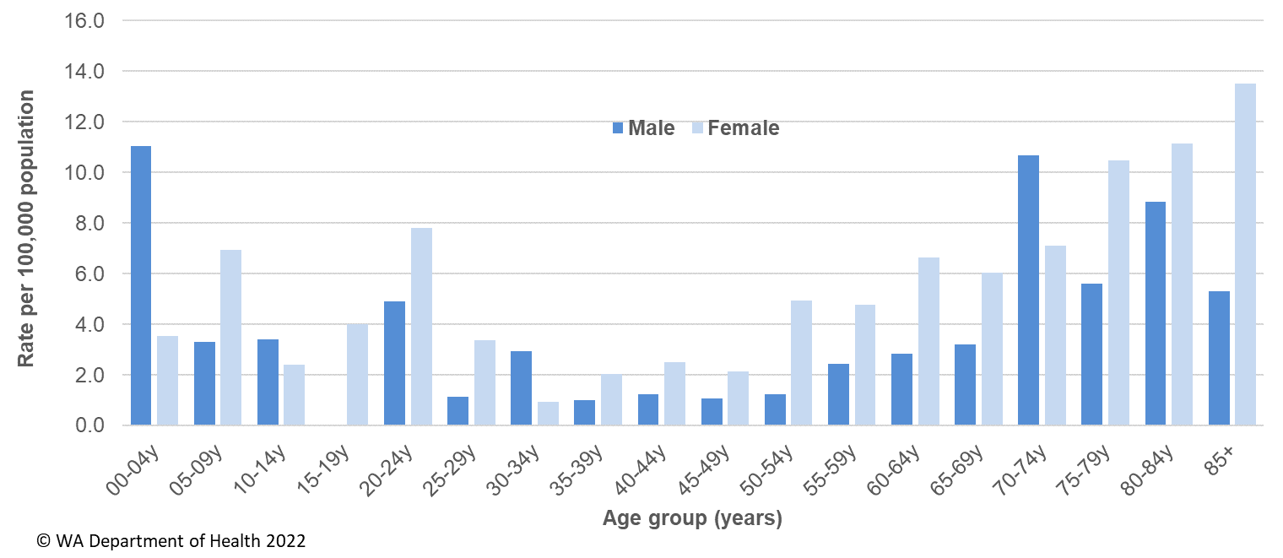

Of the 107 cases in 2021, 60% (n=64) were interviewed. An illness description was available either from the case or the case’s doctor for 94 cases and of these 56% (n=53) had an acute illness prior to testing. The remaining cases had chronic gastroenteritis symptoms or no gastroenteritis symptoms. There were 54 cases that were culture positive and the main serotypes were O157 (n=16), O128 (n=7), O91 (n=5), O76 (n=4) and O26 (n=4). Of the cases with known place of acquisition (n=92), most (99%) had acquired their infection in WA and 1% had acquired their infection overseas. Of locally acquired cases interviewed, there was one point source outbreak in two young children who were siblings and had drunk unpasteurised goats milk. There was also an investigation of four cases clustered in an area of metropolitan Perth with similar dates of onset. No common exposures were identified.

### Shigellosis

There were 100 cases of shigellosis notified in 2021, with a notification rate of 3.8 per 100,000 population. The notification rate was 58% lower than the previous five-year average (Appendix 1). Unlike previous years, in 2021 there was no increase in notifications during the summer months (Figure 18).

As of 1 July 2018 the national *Shigella* case definition changed to include notifications that are PCR positive as probable cases and culture positive notifications as confirmed cases. In 2021, there were 19 probable and 81 confirmed shigellosis cases. All the probable cases were Metropolitan residents, and of those with known place of acquisition, all were acquired in WA. In comparison, for the confirmed cases, only 23% were for Metropolitan residents, and of those with known place of acquisition, all confirmed cases acquired their infection in WA.

Figure 18 Shigellosis notifications by year and month, WA, 2016 to 2021

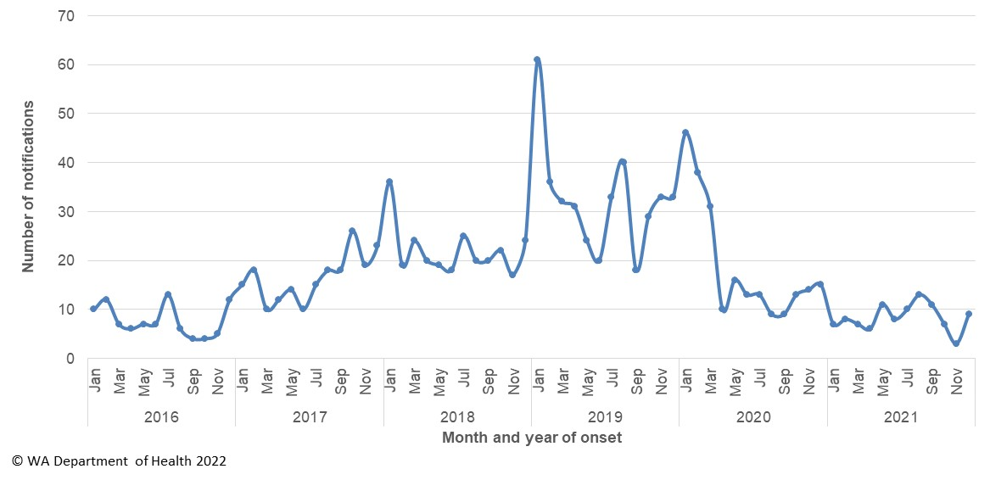

The shigellosis notification rate was 16% higher in females compared to males in 2021 (4.1 and 3.5 per 100 000 population, respectively). The 0-4 years age group had the highest rate of notification with 13.7 cases per 100 000 population (Figure 19).

Figure 19 Shigellosis notification rates by age group and sex, WA, 2020

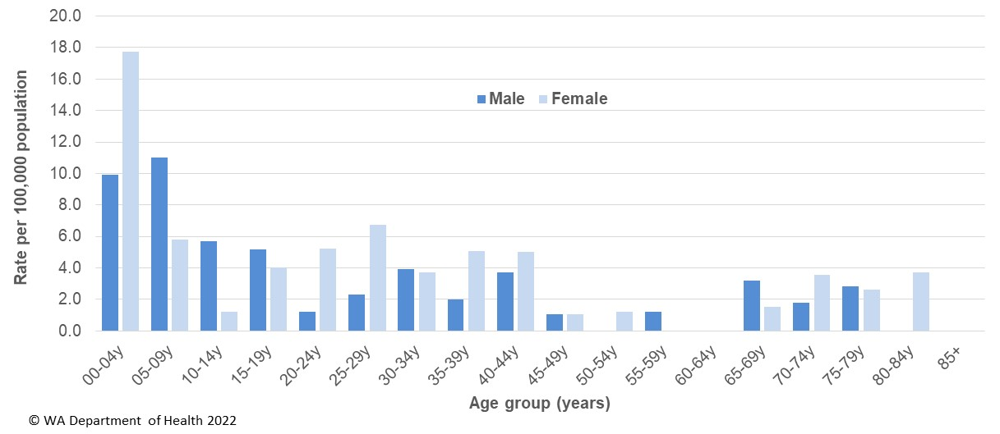

In 2021, the notification rate was 28 times higher for the Aboriginal population as compared to the non-Aboriginal population (50.4 and 1.8 per 100 000 population, respectively). The region with the highest shigellosis notification rate was Kimberley (86.2 cases per 100 000 population) followed by the Midwest and Pilbara regions (18.2 and 16.7 cases per 100 000 population, respectively) (Figure 20).

Figure 20 Shigellosis notification rates by region and Aboriginality, WA, 2021

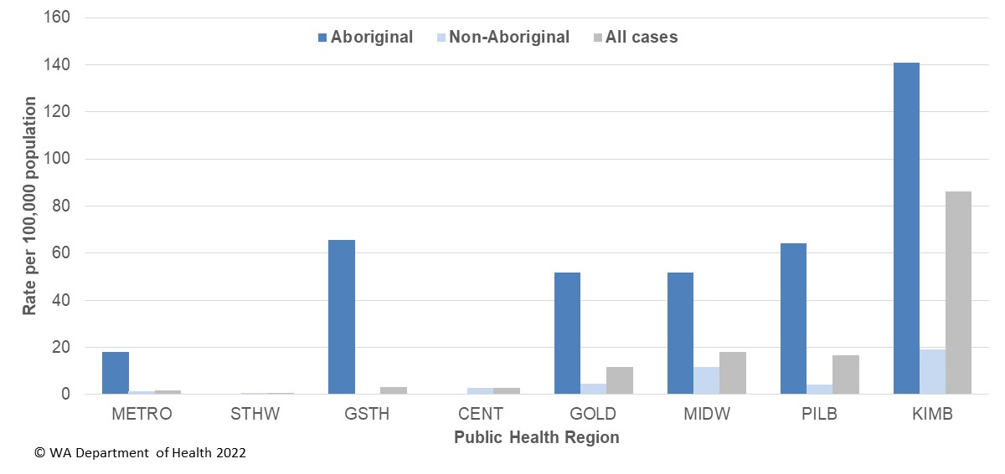

The predominant subtypes of *Shigella* notified in 2021 were *S. sonnei* biotype A (n=46) which peaked in May and *S. flexneri* 2A (n=14) which had notifications reported throughout the year. Of the notifications with known travel history, all cases acquired their infection in WA.

There were eight multi-drug resistant (MDR) *Shigella* notifications reported in 2021, compared to 22 MDR in 2020. In 2021, 6/8 MDR *Shigella* were *S. sonnei* biotype G and of these six cases all were male and five reported they were men who have sex with men. The remaining two cases were *S*. *flexneri* 2B and were Aboriginal people from the same family group.

### Typhoid and paratyphoid fever

In 2021, there was one case of typhoid fever (caused by *Salmonella* Typhi) notified, which was lower than the previous five years average of 15 notifications (Appendix 1). This case had recently returned from travel to Papua New Guinea. There were no cases of paratyphoid fever notified in WA in 2021. The decrease in typhoid and paratyphoid fever in 2021 is likely due to the overseas travel restrictions.

### *Vibrio parahaemolyticus* infection

There were 39 cases of *Vibrio parahaemolyticus* infection notified in 2021 with a rate of 1.5 cases per 100 000 population, which was 2.4 fold higher than the mean rate of the previous five years (Appendix 1). This increase was due to a multi-jurisdictional outbreak of *V. parahaemolyticus* associated with the consumption of oysters from South Australia. Of the 39 cases in WA, there were 33 cases associated with the outbreak with onsets of illness from 12th September to 19th November. Further details of the outbreak can be found in the [WA OzFoodNet 2021 4th quarter report](https://ww2.health.wa.gov.au/Articles/F_I/Infectious-disease-data/Enteric-infection-reports-and-publications-OzFoodNet). Of the remaining six cases, five had been wound infections. The sixth case had gastroenteritis and the source of illness was unknown, although they did report eating oysters in early March 2021.

### *Yersinia* infection

There were 38 cases of culture-positive *Yersinia* *enterocolitica* infection notified in 2021, with a rate of 1.4 cases per 100 000 population, which is 2.3-fold higher than the mean rate of the previous five years (Appendix 1). There were 17 female and 21 male cases with ages ranging between <1 years and 89 years. Of those cases with known travel history, all cases had acquired their illness in WA. The majority (n=23) of cases were notified by one private pathology laboratory, which uses a faecal PCR test followed by reflex culture. There were no clusters or outbreaks of *Y.* *enterocolitica* investigated in 2021.

# Gastrointestinal disease outbreaks and investigations

### Foodborne and probable foodborne outbreaks

There were 21 foodborne or probable foodborne gastroenteritis outbreaks investigated in WA in 2021 (Table 3). The number of foodborne and probable foodborne outbreaks was below the five-year average (n=29.2) with a decrease reported each year since 2017 where the number of outbreaks investigated peaked at 42. The 21 foodborne outbreaks caused at least 172 cases of gastroenteritis and 11 hospitalisations. Short descriptions of these outbreaks are provided in [2021 quarterly reports](http://ww2.health.wa.gov.au/Articles/F_I/Infectious-disease-data/Enteric-infection-reports-and-publications-OzFoodNet).

**Aetiology**

Of the 21 outbreaks, 12 were due to STM, with five outbreaks of MLVA type 03-17-09-12-523, two outbreaks of MLVA 03-18-09-12-523 and five outbreaks of unique MLVA types. This was a 50% decrease in STM outbreaks compared to the five-year average (n=24.2). A decrease in STM outbreaks has occurred since 2017. For the remaining nine outbreaks in 2021, two outbreaks were due to *Campylobacter*, one each due to *Clostridium perfringens*, norovirus, *S.* Infantis, *S.* Saintpaul, *V. parahaemolyticus* and shiga-toxin producing *E. coli*. For one outbreak the aetiology was unknown (suspected viral agent).

**Food vehicles**

The investigations of the 21 outbreaks identified food vehicles for 11 outbreaks. There were four outbreaks (19%) due to eating egg-containing dishes, which was the most common vehicle identified. This was lower than the five-year average of outbreaks associated with eggs (n=10.8). The four egg-containing dishes included raw egg sauces, breakfast egg dishes, French toast and tiramisu. All four egg-related outbreaks were caused by STM, including MLVA types 03-17-09-12-523 (n=2), and one each of 03-10-16-11-523 and 03-14-11-10-423. The egg producer and production system were able to be determined in all four of these egg-related outbreaks and included multiple egg producers, and free-range, pastured and cage production systems. This information was gathered from environmental investigations. The cause of STM outbreaks due to egg-dishes is likely due to multiple contributing factors including egg contaminated with *Salmonella*, and inadequate egg storage, handling and dish preparation. The remaining *Salmonella* Typhimurium outbreaks with food vehicles identified were due to pork dishes for one outbreak, multiple food implicated in one outbreak and unknown food vehicle for six outbreaks.

**Epidemiological investigation and evidence**

The evidence that supported the classification of 21 enteric outbreaks as foodborne or probable foodborne transmission was obtained using analytical studies for one outbreak, microbiological and descriptive studies for one outbreak and descriptive case studies (DCSs) for 19 outbreaks. The analytical studies involved interviewing those people who were at the implicated meal using a questionnaire on all foods/drinks available. These studies can be used to find a statistical association between a food eaten and illness. Microbiological evidence refers to the implicated food being positive for the same pathogen as the cases. For the outbreaks investigated as a DCS, there was strong circumstantial evidence to support probable foodborne transmission, such as ill people independently visiting a common food business, or the venue being the only source of food for cases.

**Food preparation settings**

The setting where food was prepared for the 21 foodborne outbreaks in 2021 included 13 restaurants (caused by STM n=10, *S*. Infantis n=1, norovirus n=1, unknown n=1), two supermarkets (caused by *Campylobacter in each*), two at private residences (caused by STM in each), one outbreak each at a hostel (caused by *S*. Saintpaul), prison (caused by *Clostridium perfringens*), and two at primary production (caused by STEC and *V. parahaemolyticus*).

Table 3 Foodborne and probable foodborne outbreaks, 2021



**1**Month of outbreak is the month the outbreak was first reported or investigated, whichever is earliest

2MLVA=multi-locus variable number tandem repeat analysis

### Outbreaks due to non-foodborne transmission or with an unknown mode of transmission

In 2021, there were 262 outbreaks of gastroenteritis investigated that were not classified as foodborne disease outbreaks (Table 4). These outbreaks included 246 outbreaks associated with person-to-person transmission, 14 outbreaks where the mode of transmission was unclear or unknown and one outbreak each due to probable waterborne transmission and probable zoonotic transmission (Figure 21).

**Probable person-to-person outbreaks**

Of the 246 probable person-to-person (PTP) transmission outbreaks, 159 (65%) occurred in child care centres, 70 (29%) in RCFs, nine (4%) in schools, five at mine site accommodation (2%), and three (1%) in hospitals (Table 4). The causative agent for 36 (15%) of the outbreaks was confirmed as norovirus, 12 (5%) outbreaks were due to rotavirus and one outbreak each was due to adenovirus, *Blastocystis hominis* and *Shigella*. In the remaining 195 (79%) outbreaks, the causative agent was unknown, either because specimens were not collected, a pathogen was not identified during testing, viral testing was not requested, or it was not clear from the results what the causative pathogen was. A total of 3715 people were affected by these outbreaks, with 34 hospitalisations and one associated deaths.

The number of PTP outbreaks in 2021 was 62% higher than the average of the previous five years (n=151). The increase was a result of the number of outbreaks in child care centres that where over 2.5 times higher (n=159) than the previous five years (n=62), and most (86%) were notified in the fourth quarter (Figure 21).

**Outbreaks with unknown mode of transmission**

In the 14 outbreaks where the likely mode of transmission was unclear or unknown, seven (50%) occurred in aged care facilities, four were in childcare centres, two were in restaurants/cafés, and one was in a prison (Table 4).

In these 14 outbreaks the causative agent was unknown. For these outbreaks, there was also insufficient information to attribute a mode of transmission either due to illness symptoms were diarrhoea only, there was point source outbreak but there was insufficient data to suspect a food vehicle, or the symptoms did not match a single diagnosis of a pathogen, indicating that the diagnosis may have been an incidental finding (e.g. *Campylobacter*).

**Other non-foodborne outbreaks**

There was one outbreak in 2021 due to probable waterborne transmission likely resulting from contaminated water at a caravan park. For this outbreak, 15 people reported gastroenteritis and of these cases, eight were diagnosed with *S*. Adelaide.

In 2021, there was also one outbreak due to probable zoonotic transmission with two people diagnosed with *Cryptosporidium* and who were working with dairy cows on the same farm during their incubation period.

Figure 21 Number of non-foodborne gastroenteritis outbreaks by mode of transmission and month, 2021



**Table 4 Outbreaks due to non-foodborne or unknown mode of transmission in WA by setting and agent, 2021**



1Deaths temporally associated with gastroenteritis, but contribution to death not specified

### Cluster investigations

In 2021, there were eight new clusters investigated which included seven *Salmonella* clusters and one cluster of STEC (Table 5). Cases were interviewed with standard hypothesis generating questionnaires but no hypothesis for the cause of illness could be established.

**Table 5 New cluster investigations in WA by month investigation started, setting and agent, 2021**



*MLVA=multi-locus variable number tandem repeat analysis

**Ongoing investigation - *Salmonella* Typhimurium MLVA 03-17-09-12-523**

Up until September 2016, STM MLVA 03-17-09-12-523 had not been notified in WA since MLVA typing began in WA in January 2015. Since the emergence of this strain in September 2016 to the end of 2021, there have been a total 2008 cases, 511 hospitalisations and eight deaths temporally associated with this infection in WA (Figure 22). A total of 58 point source outbreaks due to this strain have been investigated since 2016. In 28 outbreaks a food vehicle was identified, 26 were due to consumption of raw or undercooked egg or egg containing dishes. There were also 1645 community cases (were not linked to common food exposure or setting) and these cases comprised of 48% males and 52% females, with median age of 28 years (range 0 to 99 years), and most (86%) resided in the Perth metropolitan region.

In response to this ongoing investigation a *Salmonella* Outbreak Response Taskforce was established in July 2019 which included representatives from WA Department of Health, PathWest laboratory, Department of Primary Industry and Regional Development, and select Local Governments. The primary outcomes of the taskforce were to collaborate with egg producers that would include on-farm investigations of epidemiologically linked farms. In addition, there were further investigations into the association between illness and egg consumption through microbiological sampling and whole genome sequencing of isolates.

The department conducted on-site visits and sampling at epidemiologically linked farms from February 2020 onwards. STM MLVA 03-17-09-12-523 was detected on all farms with varying level of contamination found between different sheds and farms. Several recommendations were made to the egg producers in response. These improvements included general farm management in biosecurity, pest control and cleaning as well as vaccination of flocks against STM. Vaccination programs for new flocks on investigated farms commenced in June 2020. Notifications of STM MLVA 03-17-09-12-523 have decreased since October 2020 with 21 notifications in the July-Dec 2021 period compared to the previous five-year average for the same period of 155 notifications.

Figure 22 Notifications of *Salmonella* Typhimurium MLVA 03-17-09-12-523 in WA



# References

1. Hall, G., Kirk, MD., Becker, N., Gregory, JE., Unicomb, L., Millard, G., et al. Estimating foodborne gastroenteritis, Australia. Emerg Infect Dis 2005;11(8):1257-1264.
2. OzFoodNet Working Group. A health network to enhance the surveillance of foodborne diseases in Australia. Australian Government Department of Health 2020. <https://www1.health.gov.au/internet/main/publishing.nsf/Content/cdna-ozfoodnet.htm>
3. Western Australian Department of Health. A-Z list of case definitions. Western Australian Department of Health 2020. <http://ww2.health.wa.gov.au/Articles/N_R/Notification-of-infectious-diseases-and-related-conditions>.
4. Communicable Diseases Network Australia. Australian national notifiable diseases and case definitions. Australian Government Department of Health 2020

<http://www.health.gov.au/casedefinitions>

5 Ng, J., Eastwood, K., Walker, B., Durrheim, DN., Massey, PD and Porigneaux, P. Evidence of Cryptosporidium transmission between cattle and humans in northern New South Wales. Exp Parasitol 2012;130(4):437-441.

# Appendix 1: Number of notifications, notification rate2 and ratio of current to historical mean by pathogen/condition, 2016 to 2021, WA



1Abbreviations: STEC: Shiga toxin-producing *E. coli*; HUS: Haemolytic Uraemic Syndrome; NA: not applicable. 2Rate is cases per 100 000 population. 3*Shigella* includes probable and confirmed notifications as of 1st July 2018; the 5-year mean should be interpreted with caution.

**This document can be made available in alternative formats on request for a person with a disability.**

© WA Department of Health 2022

Copyright to this material is vested in the State of Western Australia unless otherwise indicated. Apart from any fair dealing for the purposes of private study, research, criticism or review, as permitted under the provisions of the *Copyright Act 1968*, no part may be reproduced or re-used for any purposes whatsoever without written permission of the State of Western Australia.